STEP 1 — Problem Understanding & Framing
  - Business Problem
Credit card fraud is a significant challenge for financial institutions because fraudulent transactions can result in financial losses, operational costs, and customer impact. Since financial institutions process a large volume of transactions, manually reviewing every transaction is not practical. This project aims to develop an intelligent credit card fraud detection system using machine learning to automatically classify transactions as legitimate or fraudulent and identify potentially suspicious transactions for further review.
  - Data Science Problem
This project is a supervised machine learning problem focused on binary classification. The objective is to classify credit card transactions into two classes: legitimate transactions (Class 0) and fraudulent transactions (Class 1). The model learns patterns from historical labeled transactions and applies these patterns to classify previously unseen transactions.
Classification is appropriate because the target variable represents two discrete categories rather than a continuous numerical value. The model predicts whether a transaction belongs to the legitimate class (0) or fraudulent class (1), making this a binary classification problem rather than a regression problem.
  - Proposed System
The proposed system uses a machine learning model to analyze transaction features and estimate the likelihood that a transaction is fraudulent. The system produces a classification result and fraud probability, which can be used to support operational actions such as approving legitimate transactions or routing suspicious transactions for further review.
Credit Card Transaction
↓
Data Processing
↓
Machine Learning
↓
Fraud Probability
↓
┌────────┴─────────┐
↓ ↓
LEGITIMATE FRAUDULENT
↓ ↓
APPROVE REVIEW/BLOCK

  - Technical Success Metrics
The model will be evaluated using multiple performance metrics, including accuracy, precision, recall, F1-score, and ROC-AUC. Accuracy provides an overall measure of correct predictions, while precision measures the proportion of predicted fraudulent transactions that are actually fraudulent. Recall measures the proportion of actual fraudulent transactions that are correctly detected. F1-score provides a balance between precision and recall, while ROC-AUC measures the model's ability to distinguish between legitimate and fraudulent transactions. Because credit card fraud datasets are typically highly imbalanced, accuracy alone will not be considered sufficient for evaluating model performance.
Metric | Meaning
Accuracy | Overall correct predictions
Precision | Kapag sinabi ng model na fraud, gaano kadalas tama
Recall | Ilang actual fraud ang nahuli
F1-score | Balance ng Precision at Recall
ROC-AUC | Ability ng model na paghiwalayin ang fraud at legitimate

  - Business KPIs
In addition to technical model metrics, the project will consider business-oriented KPIs. These include the fraud detection rate, false positive rate, false negative rate, review rate, and potential fraudulent transaction value identified by the system. These measures help assess the operational usefulness of the model, including its ability to detect suspicious transactions while minimizing unnecessary intervention on legitimate customers.

  - Business Impact
A machine learning-based fraud detection system can support financial institutions by automatically screening large volumes of transactions, prioritizing potentially suspicious transactions for investigation, and reducing the amount of manual transaction screening required. The system may also support faster fraud response and help identify potentially fraudulent transaction value. However, actual financial savings would require validation using real operational and deployment data.

STEP 2 — Data Collection & Understanding
2.1 Dataset Selection & Justification
The selected dataset is appropriate for this project because it contains historical credit card transaction records with a binary fraud label. It includes both legitimate and fraudulent transactions, allowing the development of a supervised machine learning classification model. The dataset also contains numerical transaction features and transaction amounts that can be analyzed to identify patterns associated with fraudulent activity. Its labeled structure makes it suitable for training, testing, and evaluating machine learning fraud detection models.

2.2 Dataset Source
The project uses the Credit Card Fraud Detection dataset. The original dataset source and citation will be documented in the final report to ensure proper attribution and reproducibility.
2.3 Load the Dataset
import pandas as pd

df = pd.read_csv(
r"C:\Users\edmig\OneDrive\DESKTOP\2_Credit-Card-Fraud-Detection\creditcard.csv"
)

df.head()

2.4 Dataset Size
The dataset contains 284,807 transaction records and 31 variables. Of the 31 variables, 30 are transaction-related input features, while Class is the binary target variable used to identify legitimate and fraudulent transactions.
2.5 Column Names
The dataset contains the Time variable, 28 anonymized numerical variables (V1–V28), the transaction Amount, and the binary target variable Class.
2.6 Data Types
The dataset is primarily composed of numerical variables. Time, V1 through V28, and Amount are stored as floating-point numerical variables (float64). The Class variable is stored as an integer (int64) and represents the binary target, where 0 indicates a legitimate transaction and 1 indicates a fraudulent transaction.
2.7 Missing Values
The dataset was examined for missing values across all 31 variables. The analysis showed zero missing values in every column. Therefore, no missing-value imputation was required for the dataset.
2.8 Duplicate Records
The dataset contains 1,081 duplicate rows. These duplicate observations will be reviewed and appropriately handled during the preprocessing stage because duplicated records may affect model training and the reliability of model evaluation.
2.9 Class Distribution
The dataset is highly imbalanced. There are 284,315 legitimate transactions (99.8273%) and only 492 fraudulent transactions (0.1727%) out of 284,807 total transactions. This substantial class imbalance is an important consideration for model development and evaluation. Therefore, accuracy alone will not be sufficient for evaluating the fraud detection model, and precision, recall, F1-score, and ROC-AUC will also be considered.
2.10 Statistical Summary
print("Statistical Summary:")
display(df.describe())
2.11 Time Analysis
The Time variable ranges from 0 to 172,792 seconds, with a mean of approximately 94,813.86 seconds. It represents the elapsed time of each transaction relative to the first transaction recorded in the dataset.
2.12 Amount Analysis
The Amount variable has a mean of 88.35 and a median of 22.00, while its values range from 0 to 25,691.16. The substantial difference between the mean and median suggests that the distribution may be positively skewed, with a relatively small number of high-value transactions influencing the mean. This will be investigated further during the exploratory data analysis stage.
2.13 V1–V28 Analysis
The V1–V28 variables are anonymized PCA-transformed numerical features. They contain both positive and negative values and should not be interpreted as direct business variables such as age, income, location, or customer demographics. Their transformed values will instead be used as numerical predictors for the machine learning models.

2.14 Outlier Analysis
The descriptive statistics indicate the presence of potentially extreme observations, particularly in the Amount variable and some anonymized features. These observations will not automatically be removed because unusual transaction patterns may contain valuable information for fraud detection. Further analysis using statistical methods and visualizations will be performed during the EDA and preprocessing stage.
2.15 Data Dictionary
Variable | Type | Description | Unit / Interpretation
Time | Numerical | Time elapsed from the first transaction | Seconds
V1–V28 | Numerical | Anonymized PCA-transformed transaction features | Transformed numerical values
Amount | Numerical | Transaction amount | Currency amount
Class | Binary | Target variable | 0 = Legitimate, 1 = Fraudulent
The dataset contains one time-related numerical variable (Time), 28 anonymized PCA-transformed numerical features (V1–V28), one transaction amount variable (Amount), and one binary target variable (Class). The Class variable contains two possible values: 0 for legitimate transactions and 1 for fraudulent transactions.

Code
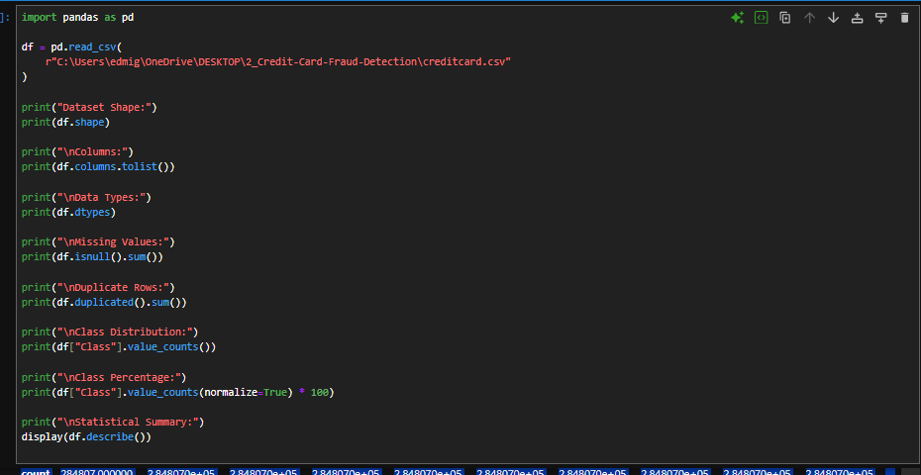
Output
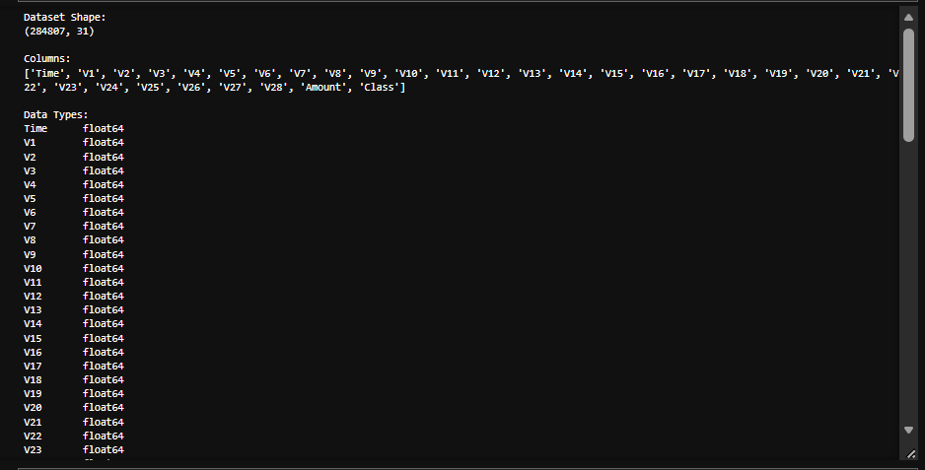
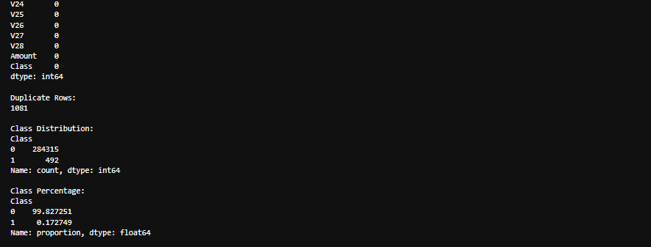
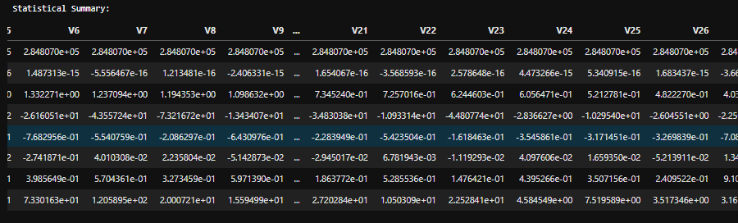

STEP 3 — Data Preprocessing, EDA & Feature Engineering

STEP 3 → Part A — DATA PREPROCESSING
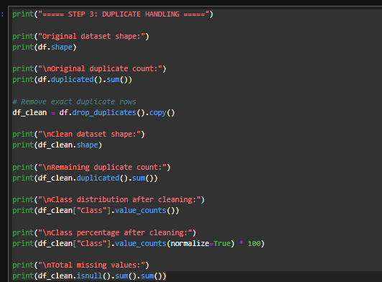
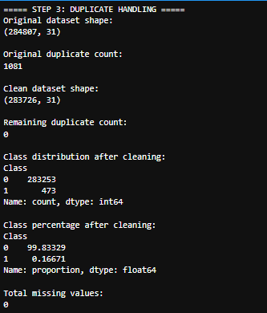
Data Preprocessing
The dataset was first examined to identify missing values and duplicate records. The original dataset contained 284,807 records and 31 variables. No missing values were found; however, 1,081 duplicate records were identified.
Exact duplicate records were removed using the drop_duplicates() method. After preprocessing, the dataset contained 283,726 records and 31 variables, with zero remaining duplicate records and no missing values.
The cleaned dataset contained 283,253 legitimate transactions (99.83329%) and 473 fraudulent transactions (0.16671%). The class distribution indicates a severe imbalance between legitimate and fraudulent transactions, which will be considered during the exploratory data analysis and model development stages.
Why this preprocessing was performed
Duplicate records were removed to prevent repeated observations from potentially affecting the analysis and machine learning models. Missing-value checking was also performed to ensure that the dataset did not contain incomplete records that could cause problems during model training.

STEP 3 → Part B — Outlier Analysis
Outlier analysis was performed to identify observations with unusually high or low values. Boxplots were used to visually examine the distribution of the numerical features and identify potential outliers. Since this dataset is designed for credit card fraud detection, unusual observations may contain important information related to fraudulent behavior. Therefore, potential outliers were not automatically removed. Further analysis was conducted using the Interquartile Range (IQR) method to quantify the potential outliers.
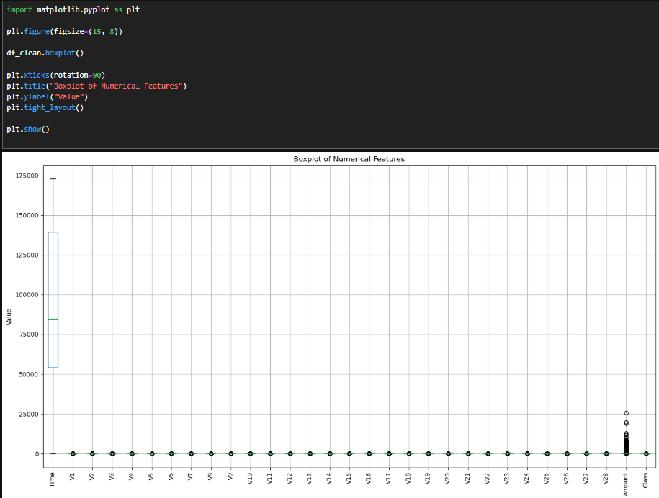

STEP 3 → Part B— IQR Analysis
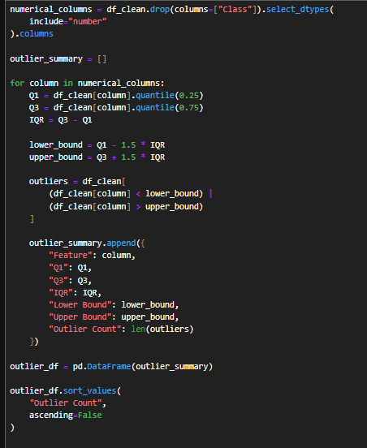
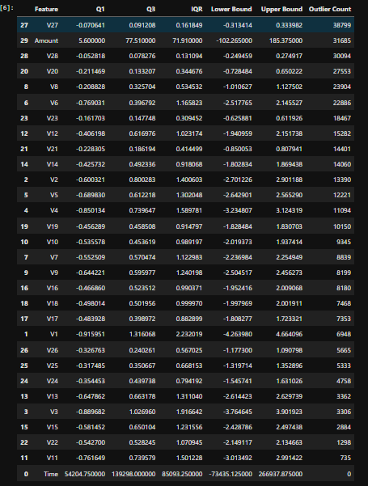
Outlier analysis was conducted using boxplots and the Interquartile Range (IQR) method. The boxplot visualization showed that several numerical features contained observations outside their typical ranges. The IQR analysis further identified potential outliers across most of the numerical features. For example, V27 had 38,789 potential outliers, while the Amount feature had 31,685 potential outliers.
These observations were not automatically removed because extreme values may contain important information for credit card fraud detection. Fraudulent transactions may exhibit unusual patterns compared with legitimate transactions. Therefore, the identified observations were retained for subsequent analysis and model development rather than being treated as erroneous data.
The Class target variable was excluded from outlier analysis because it is a binary categorical target rather than a continuous numerical feature. The Time feature had no observations classified as potential outliers using the IQR rule.

STEP 3 → Part C — EDA #1: Class Distribution
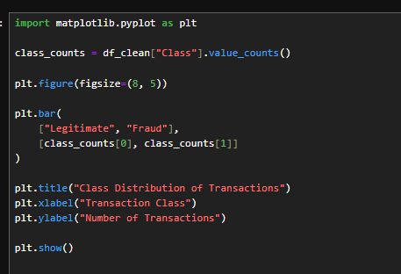
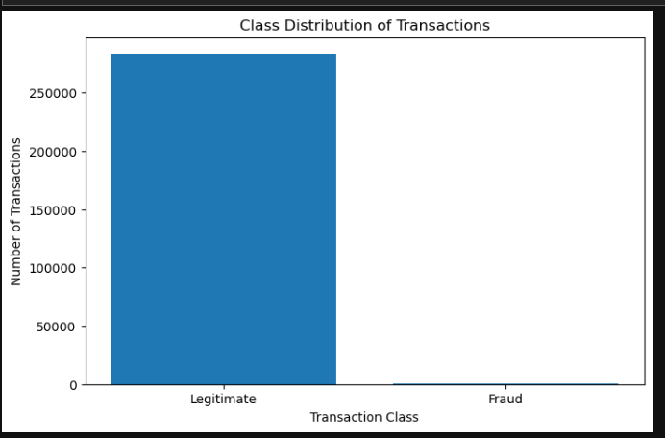
Class Distribution
The class distribution shows a severe imbalance between legitimate and fraudulent transactions. After preprocessing, the dataset contained 283,253 legitimate transactions and 473 fraudulent transactions. Legitimate transactions represented approximately 99.83% of the dataset, while fraudulent transactions represented only 0.17%.
This imbalance is an important characteristic of the dataset because a model could achieve high accuracy by predominantly predicting legitimate transactions while failing to detect fraudulent transactions. Therefore, additional evaluation metrics such as precision, recall, F1-score, and ROC-AUC will be considered during model evaluation.

STEP 3 → Part C — EDA #2: Transaction Amount Distribution
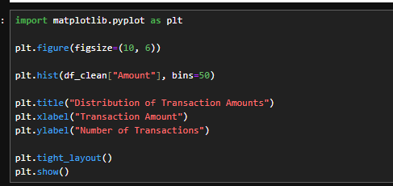
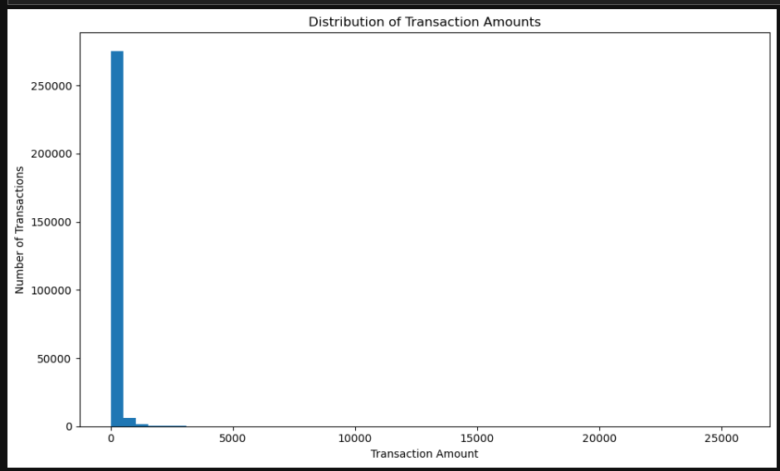
The transaction amount distribution was examined using a histogram. The visualization shows a strongly right-skewed distribution, with most transactions concentrated at relatively low amounts and a smaller number of transactions having substantially higher values. The dataset has a mean transaction amount of 88.35, while the median is 22.00, indicating that high-value transactions increase the average. The maximum transaction amount is 25,691.16.
This skewed distribution is an important characteristic of the dataset because transaction amount may provide useful information for distinguishing fraudulent and legitimate transactions. The extreme values were retained because they may represent legitimate high-value transactions or potentially informative fraud-related behavior.

STEP 3 → Part C — EDA #3: Transaction Time Distribution
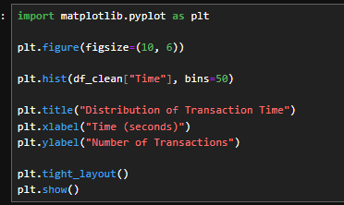
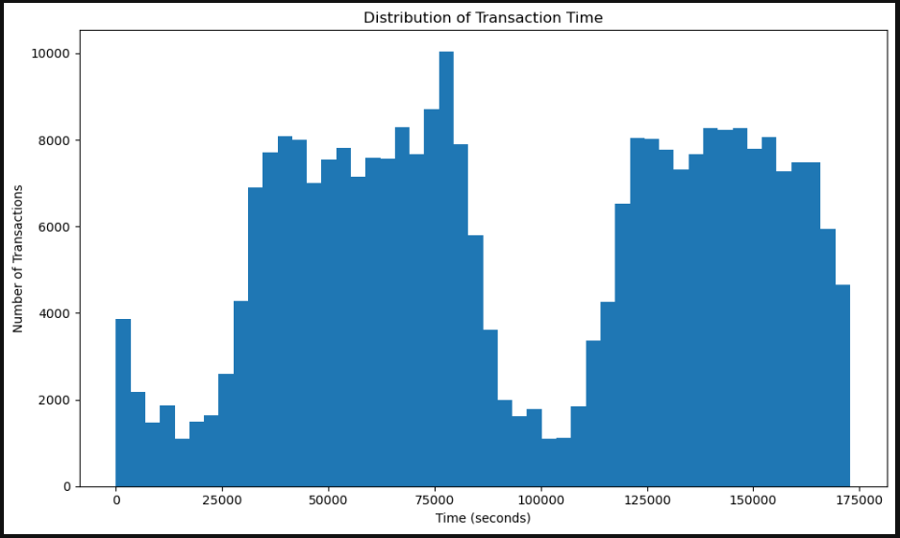
The distribution of transaction time was examined using a histogram. The results show that transaction activity is not uniformly distributed throughout the observation period. Higher concentrations of transactions can be observed during approximately 30,000–85,000 seconds and 120,000–170,000 seconds, while transaction activity decreases around 90,000–115,000 seconds.
The Time variable represents the elapsed time in seconds from the first transaction in the dataset rather than an actual clock time. Therefore, the observed patterns indicate differences in transaction activity throughout the observation period rather than specific times of day. This variable may provide useful temporal information for fraud detection.

STEP 3 → Part C— EDA #4 — Fraud vs Legitimate Transaction Amount
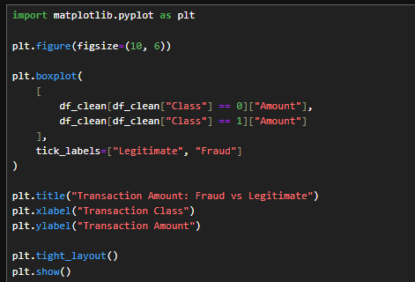
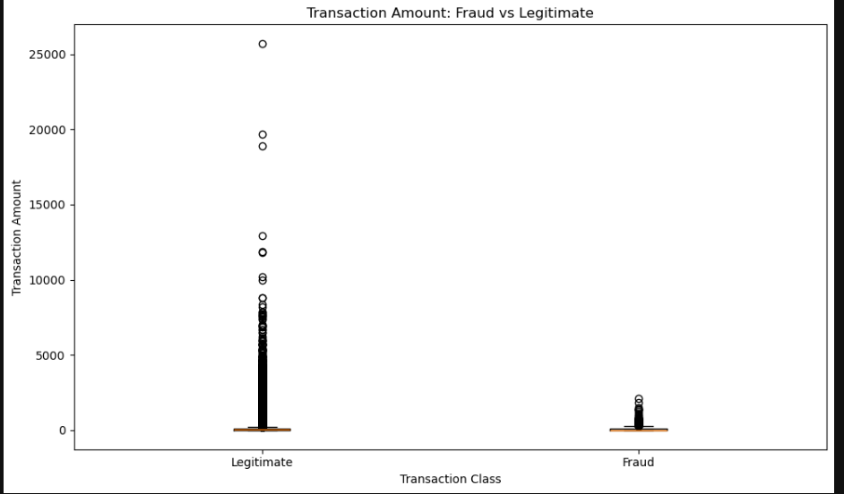
Fraud vs Legitimate Transaction Amount
A boxplot was used to compare transaction amounts between legitimate and fraudulent transactions. Both classes show right-skewed distributions, with most observations concentrated at relatively lower transaction amounts and a smaller number of higher-value transactions.
Legitimate transactions contain a wider range of transaction amounts, including extreme values reaching approximately 25,691. Fraudulent transactions are more concentrated within a lower amount range, although some fraudulent transactions also have relatively higher amounts.
The results indicate that transaction amount may provide useful information for fraud detection, but it is not sufficient as a standalone indicator of fraud. Therefore, the Amount feature should be evaluated together with the other transaction features during model development.

STEP 3 → Part C— EDA #5 : Fraud vs Legitimate Transaction Time
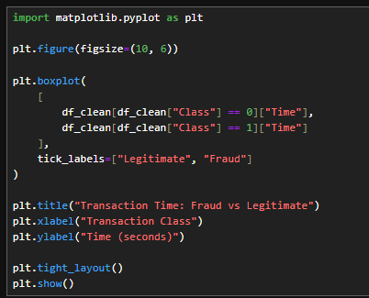
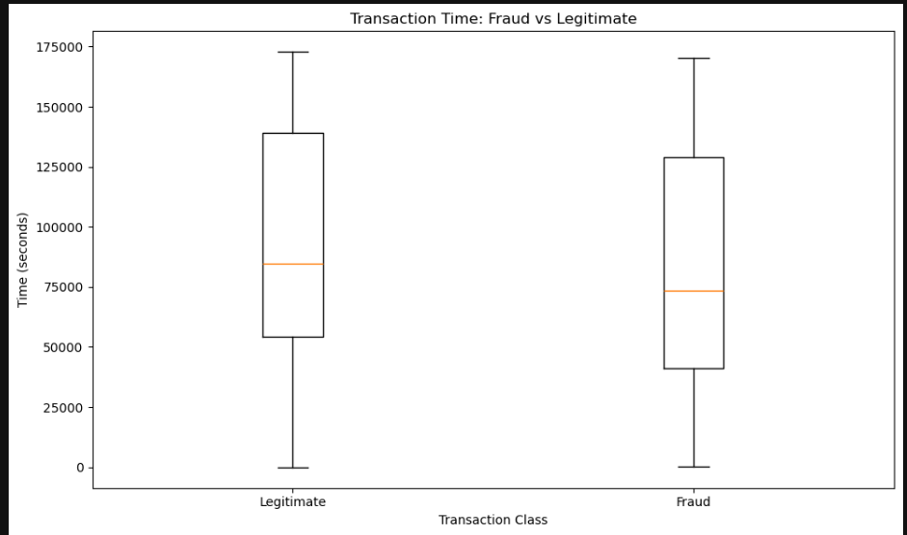
Fraud vs Legitimate Transaction Time
A boxplot was used to compare the transaction time distributions between legitimate and fraudulent transactions. The median transaction time for legitimate transactions is approximately 84,000 seconds, while the median for fraudulent transactions is approximately 73,000 seconds. Both classes show a wide distribution across the observation period and substantial overlap between their ranges.
The results suggest that transaction time may contain useful information for identifying differences between legitimate and fraudulent transactions. However, the substantial overlap between the two classes indicates that Time alone is unlikely to be sufficient for reliable fraud classification. Therefore, it will be considered together with other transaction features during model development.

STEP 3 → Part D — Correlation Analysis
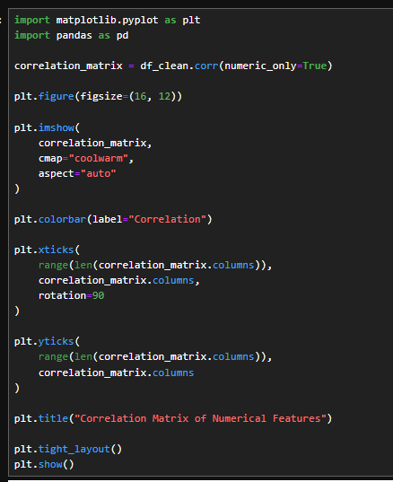
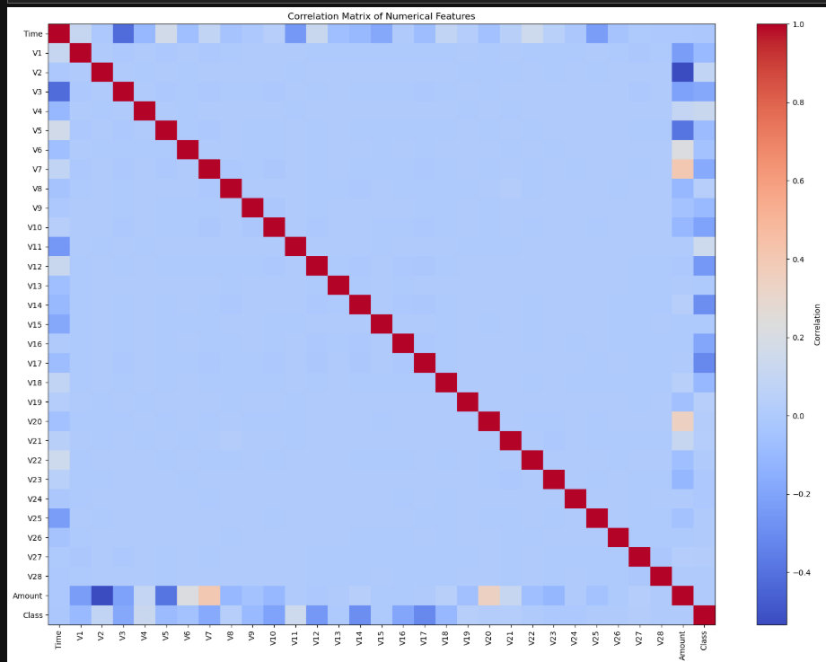

STEP 3 → Part D — Correlation with Fraud Target
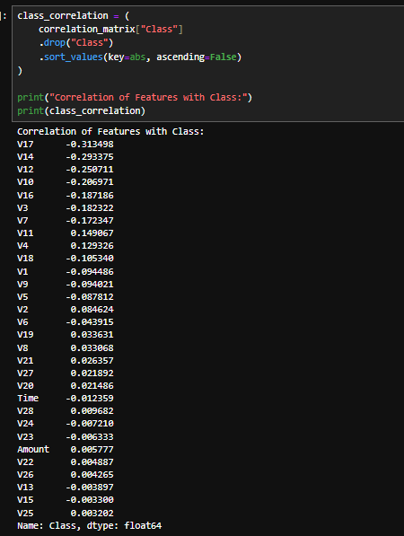
A correlation analysis was performed to examine the linear relationships among the numerical variables and the fraud target. The correlation matrix showed relatively low correlations among most of the anonymized PCA-transformed features, although some features exhibited stronger relationships with the Class variable.
The strongest negative correlations with the fraud target were observed for V17 (-0.313498), V14 (-0.293375), and V12 (-0.256711). The strongest positive correlations were observed for V11 (0.149067), V4 (0.129326), and V18 (0.105340).
The Time and Amount variables showed very weak linear correlations with the target, with correlation coefficients of -0.012359 and 0.005777, respectively. However, a weak linear correlation does not necessarily mean that a feature has no predictive value, because machine learning models can capture nonlinear relationships and interactions between variables.
Since V1–V28 are anonymized PCA-transformed features, their correlation values were interpreted as statistical relationships rather than direct business meanings. Correlation analysis was used as an exploratory and feature-selection aid rather than as the sole basis for removing variables.

STEP 3 → Part E — Feature Engineering
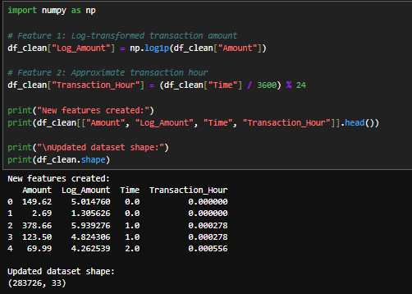
Feature Engineering
Feature engineering was performed to create additional variables that may provide useful information for fraud detection. First, a log-transformed transaction amount feature, Log_Amount, was created using the natural logarithm of one plus the original transaction amount. This transformation was introduced because the Amount variable showed a strongly right-skewed distribution during exploratory data analysis.
Second, a derived temporal feature called Transaction_Hour was created from the Time variable by converting elapsed seconds into an approximate hourly representation using a 24-hour cycle. This feature was created to provide a more interpretable temporal representation that may help capture recurring transaction-time patterns.
After feature engineering, the dataset increased from 31 to 33 variables, while the number of observations remained 283,726.

STEP 3 → Part F — Feature Selection
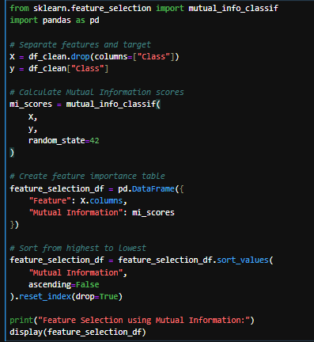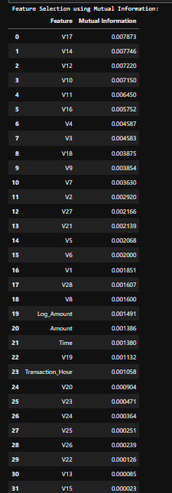
Feature Selection Using Mutual Information
Mutual Information was used as a feature selection technique to identify variables that contain useful information about the fraud classification target. The analysis ranked the input features according to their Mutual Information scores.
The top-ranked features were V17 (0.007873), V14 (0.007746), V12 (0.007220), V10 (0.007150), and V11 (0.006450). The top ten features were V17, V14, V12, V10, V11, V16, V4, V3, V18, and V9.
The results provide a data-driven basis for identifying potentially informative variables while reducing the number of features considered in subsequent analysis. Mutual Information was selected because it can capture statistical dependencies beyond simple linear correlation.
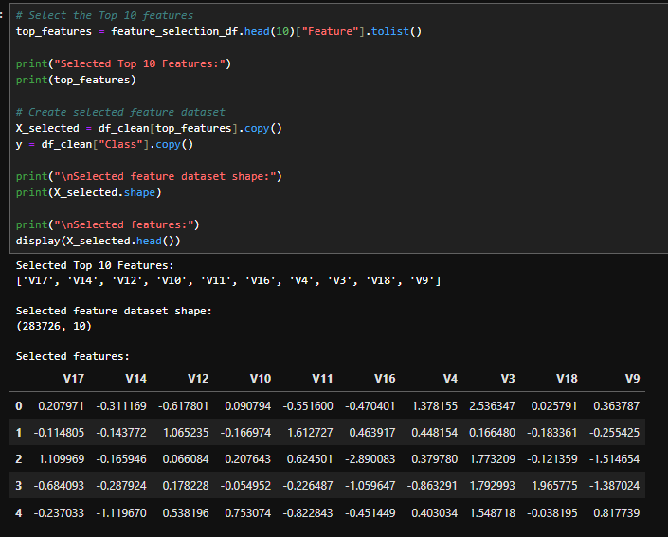
Feature Selection
Mutual Information was used to perform feature selection and identify variables with useful statistical dependencies with the fraud classification target. Based on the Mutual Information scores, the ten highest-ranked features were V17, V14, V12, V10, V11, V16, V4, V3, V18, and V9.
A selected feature dataset was then created containing these ten variables and 283,726 observations. The original cleaned dataset was retained, while the selected features were stored separately for subsequent analysis. This approach provides a reduced feature set while preserving the most informative variables identified by the feature selection method.

STEP 3 → Part G — Dimensionality Reduction
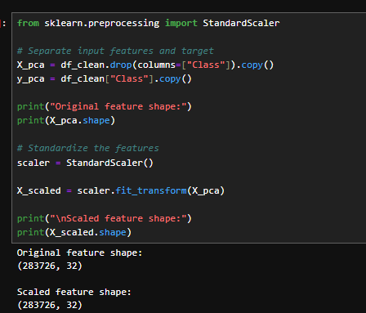
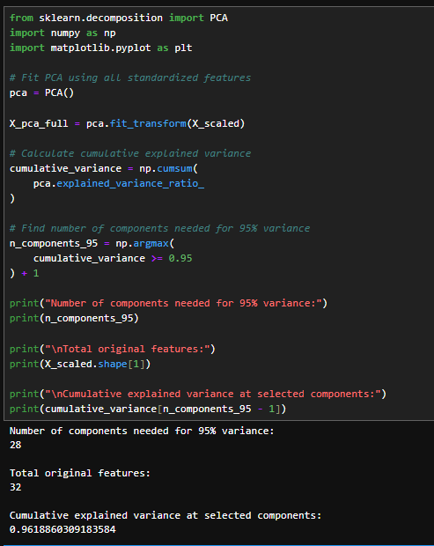
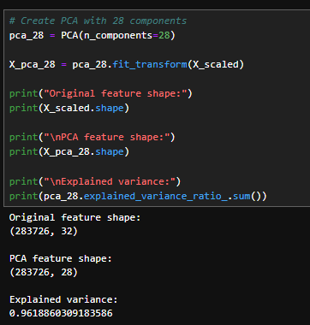
Dimensionality Reduction Using PCA
Principal Component Analysis (PCA) was applied to reduce the dimensionality of the feature set. The input variables were first standardized using StandardScaler before applying PCA. The original dataset contained 32 input features.
Based on the explained variance analysis, 28 principal components were selected. The resulting PCA dataset contained 283,726 observations and 28 components. These components retained approximately 96.19% of the total variance of the standardized input features.
Therefore, PCA successfully reduced the feature space from 32 to 28 dimensions while preserving most of the variance in the original data.

Step 3 Summary
Part | Topic
Part A | Data Preprocessing
Part B | Outlier Analysis
Part C | Exploratory Data Analysis
Part D | Correlation Analysis
Part E | Feature Engineering
Part F | Feature Selection
Part G | Dimensionality Reduction

STEP 4—Model Implementation & Comparison

STEP 4 → Part A — Train/Test Split & Modeling Setup
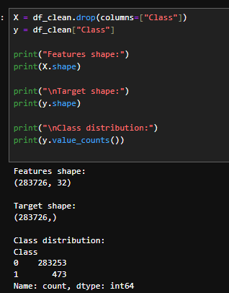
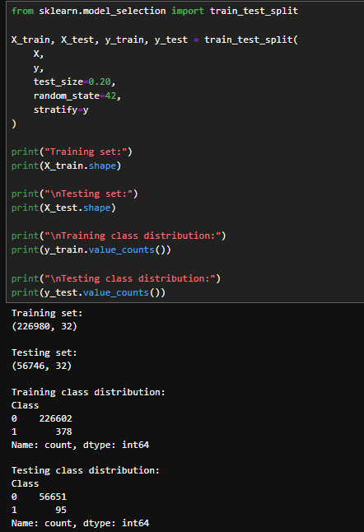
Train-Test Split
The cleaned dataset was divided into training and testing sets using an 80:20 split. Stratified sampling was applied to preserve the highly imbalanced class distribution across both subsets. The resulting training set contained 226,980 observations with 378 fraudulent transactions, while the testing set contained 56,746 observations with 95 fraudulent transactions. The same 32 input features were retained in both datasets.
The training set was used to develop the machine learning models, while the testing set was reserved for evaluating model performance on unseen data. The use of stratified sampling ensures that the proportion of fraudulent and legitimate transactions remains approximately consistent between the training and testing sets.

STEP 4 → Part B — Baseline Models
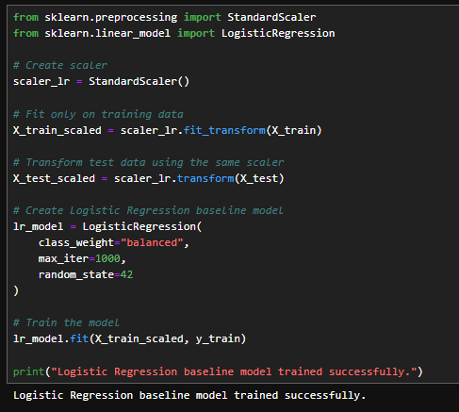
Baseline Logistic Regression
Logistic Regression was implemented as the first baseline classification model. Since the dataset is highly imbalanced, the class_weight="balanced" parameter was used to assign greater importance to the minority fraud class. StandardScaler was fitted using only the training data and then applied to both the training and testing datasets to prevent data leakage. The model was trained using the training dataset and will subsequently be evaluated using the unseen testing dataset.
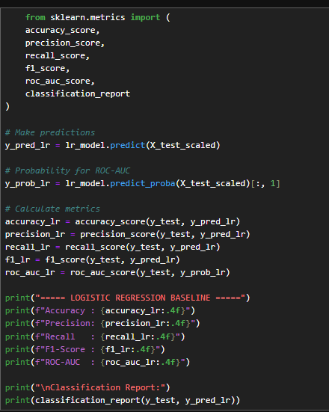
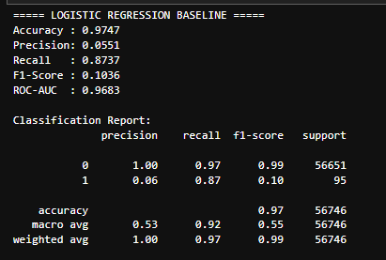
Logistic Regression Baseline Results
The Logistic Regression baseline achieved an accuracy of 97.47%, precision of 5.51%, recall of 87.37%, F1-score of 10.36%, and ROC-AUC of 96.83%.
The high recall indicates that the model was able to identify a large proportion of the fraudulent transactions in the test set. However, its precision was substantially lower, indicating that many transactions classified as fraudulent were actually legitimate. Consequently, the F1-score was also relatively low.
The results demonstrate the importance of using multiple evaluation metrics for this highly imbalanced fraud detection problem. Although accuracy was high, it did not fully represent the model's ability to distinguish fraudulent transactions because legitimate transactions greatly outnumbered fraudulent transactions.

STEP 4 → Part B — Baseline Model #2: Decision Tree
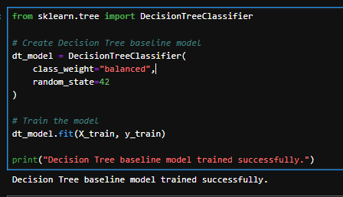
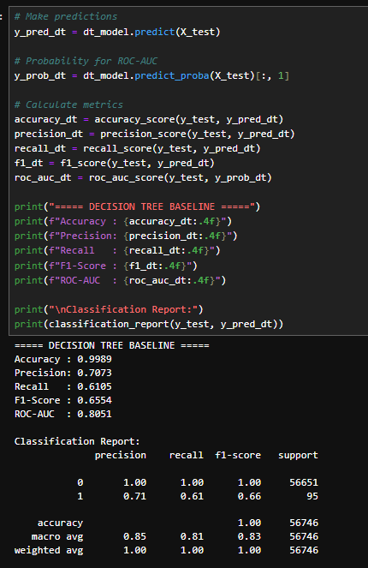
Decision Tree Baseline Results
The Decision Tree baseline achieved an accuracy of 99.89%, precision of 70.73%, recall of 61.05%, F1-score of 65.54%, and ROC-AUC of 80.51%.
Compared with the Logistic Regression baseline, the Decision Tree achieved substantially higher precision and F1-score but a lower recall and ROC-AUC. The results demonstrate that different algorithms can produce different trade-offs between detecting fraudulent transactions and minimizing false positive predictions.
Because the dataset is highly imbalanced, model performance will continue to be evaluated using multiple metrics rather than accuracy alone.

STEP 4 → Part B — Baseline Model #3: Random Forest
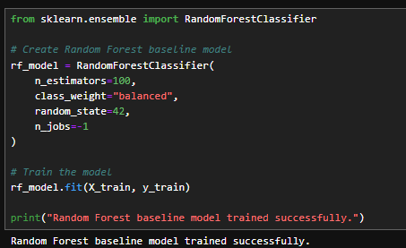
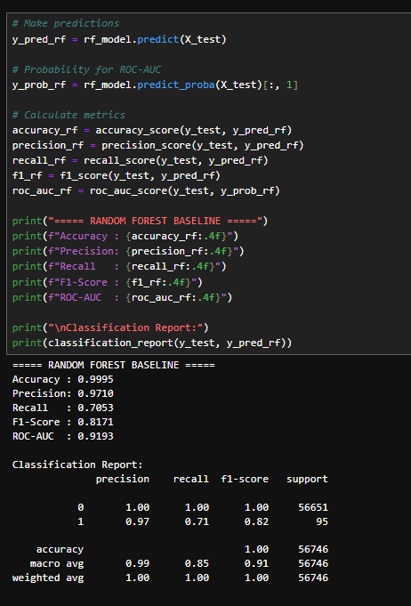
Random Forest Baseline Results
The Random Forest baseline achieved an accuracy of 99.95%, precision of 97.10%, recall of 70.53%, F1-score of 81.71%, and ROC-AUC of 91.93%.
The model achieved substantially higher precision and F1-score compared with the Logistic Regression and Decision Tree baselines. Its precision indicates that most transactions classified as fraudulent were actually fraudulent, while its recall indicates that the model detected approximately 70.53% of the fraudulent transactions in the test set.
These results demonstrate the potential of ensemble tree-based methods for capturing nonlinear patterns in credit card transaction data. However, additional models and hyperparameter tuning are required before selecting the final model.

STEP 4 → Part B — Baseline Model #4: Gradient Boosting
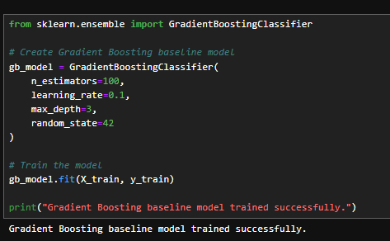
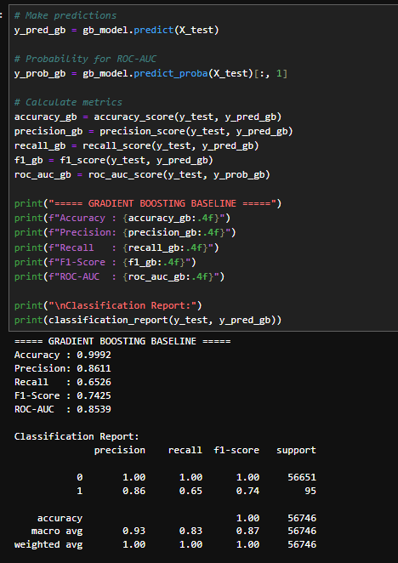
Gradient Boosting Baseline Results
The Gradient Boosting baseline achieved an accuracy of 99.92%, precision of 86.11%, recall of 63.16%, F1-score of 74.25%, and ROC-AUC of 85.39%.
The model demonstrated relatively high precision, indicating that a large proportion of transactions classified as fraudulent were actually fraudulent. However, its recall of 63.16% indicates that a considerable number of fraudulent transactions were not detected. The F1-score provides a more balanced assessment of the model's precision and recall.
These results further demonstrate the differences in model behavior when applied to the highly imbalanced fraud detection dataset.

STEP 4 → Part B — Baseline Model #5: XGBoost
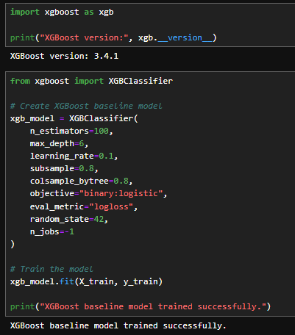
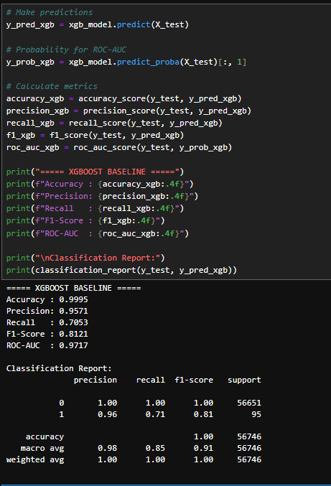
XGBoost Baseline Results
The XGBoost baseline achieved an accuracy of 99.95%, precision of 95.71%, recall of 70.53%, F1-score of 81.21%, and ROC-AUC of 97.17%.
The model achieved high precision, indicating that most transactions classified as fraudulent were actually fraudulent. Its recall of 70.53% indicates that it detected approximately 70% of the fraudulent transactions in the unseen test set. The model also achieved a strong ROC-AUC of 97.17%, indicating strong discrimination between legitimate and fraudulent transactions based on its predicted probabilities.
Overall, the baseline results demonstrate that XGBoost can effectively model the nonlinear patterns present in the credit card transaction data. However, further hyperparameter tuning and evaluation are required before determining the final model configuration.

COMPLETE BASELINE COMPARISON
Model | Accuracy | Precision | Recall | F1-Score | ROC-AUC
Logistic Regression | 97.47% | 5.51% | 87.37% | 10.36% | 96.83%
Decision Tree | 99.89% | 70.73% | 61.05% | 65.54% | 80.51%
Random Forest | 99.95% | 97.10% | 70.53% | 81.71% | 91.93%
Gradient Boosting | 99.92% | 86.11% | 63.16% | 74.25% | 85.39%
XGBoost | 99.95% | 95.71% | 70.53% | 81.21% | 97.17%

STEP 4 → Part C — Model Evaluation & Comparison
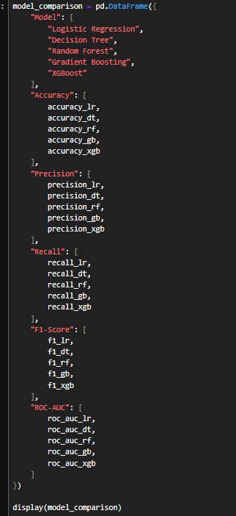
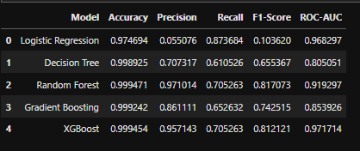
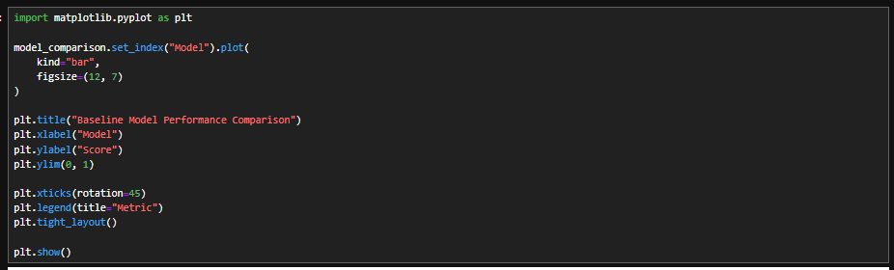
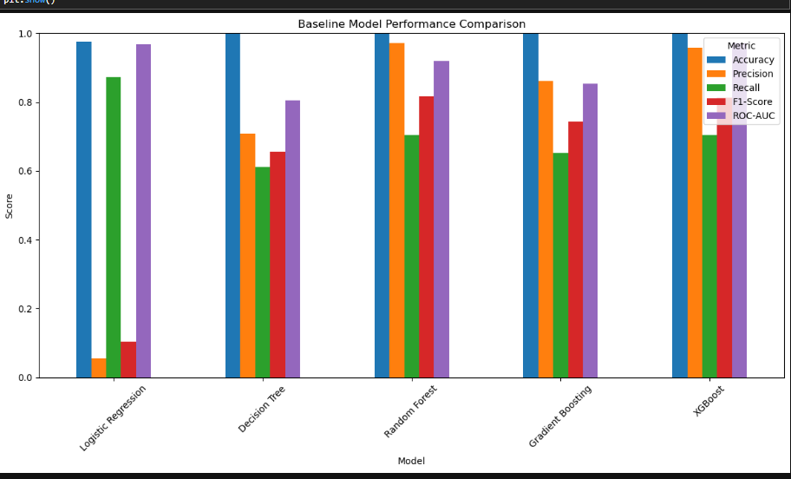
Model Evaluation and Comparison
Five baseline machine learning models were evaluated using accuracy, precision, recall, F1-score, and ROC-AUC. The results demonstrated different performance characteristics across the models.
Logistic Regression achieved the highest recall at 87.37%, but its precision was only 5.51%, indicating a large number of false positive predictions. Decision Tree achieved 70.73% precision and 61.05% recall, while Gradient Boosting achieved 86.11% precision and 63.16% recall.
Random Forest achieved 97.10% precision, 70.53% recall, and an 81.71% F1-score. XGBoost achieved 95.71% precision, 70.53% recall, an 81.21% F1-score, and the highest ROC-AUC among the evaluated models at 97.17%.
The comparison demonstrates that accuracy alone is not sufficient for evaluating fraud detection models because of the severe class imbalance. Precision, recall, F1-score, and ROC-AUC provide additional information about the models' ability to identify fraudulent transactions and manage false positive predictions.

STEP 4 → Part D — Hyperparameter Tuning
Part D — Step 1: Tune XGBoost
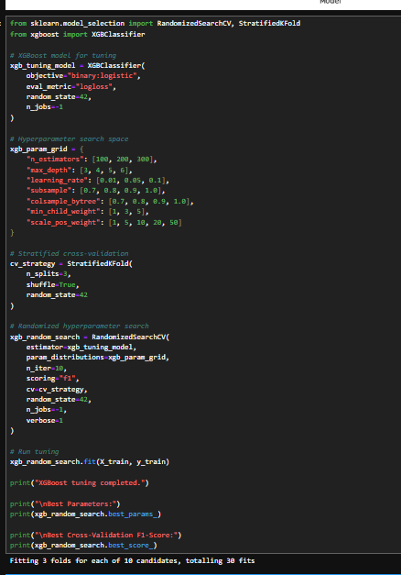

STEP 4 → Part D → Tuned XGBoost Evaluation on the Unseen Test Set
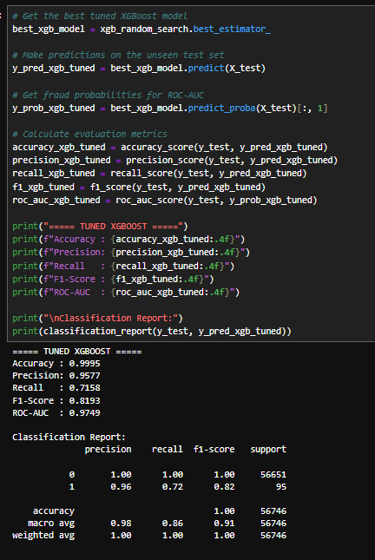
Hyperparameter Tuning Results
XGBoost hyperparameter tuning was performed using RandomizedSearchCV with stratified 3-fold cross-validation. The F1-score was used as the optimization metric because the dataset is highly imbalanced and both precision and recall are important for fraud detection.
The tuned XGBoost model achieved an accuracy of 99.95%, precision of 95.77%, recall of 71.58%, F1-score of 81.93%, and ROC-AUC of 97.49% on the unseen test set.
Compared with the baseline XGBoost model, the tuned model showed improvements in precision, recall, F1-score, and ROC-AUC, while accuracy remained unchanged at 99.95%. The F1-score increased from 81.21% to 81.93%, while ROC-AUC increased from 97.17% to 97.49%. These results indicate that hyperparameter tuning provided a measurable improvement in model performance.
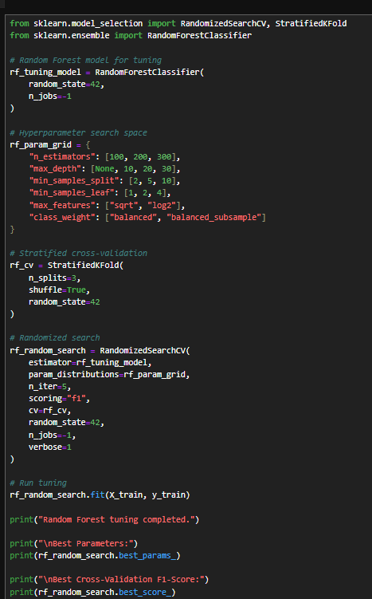
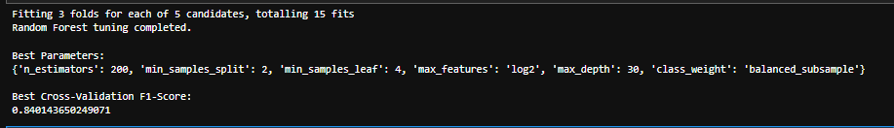
Random Forest Hyperparameter Tuning
Random Forest hyperparameter tuning was performed using RandomizedSearchCV with stratified 3-fold cross-validation. Five hyperparameter combinations were evaluated, resulting in a total of 15 model fits. The optimization metric was the F1-score to account for the highly imbalanced fraud classification problem.
The best configuration used 200 estimators, a maximum tree depth of 30, log2 feature selection, a minimum of 4 samples per leaf, a minimum of 2 samples for splitting, and balanced_subsample class weighting. The best cross-validation F1-score was 0.8401.
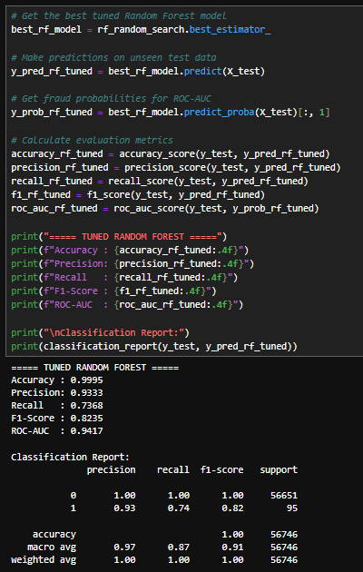
Tuned Random Forest Results
The tuned Random Forest achieved an accuracy of 99.95%, precision of 93.33%, recall of 73.68%, F1-score of 82.35%, and ROC-AUC of 94.17% on the unseen test set.
Compared with the baseline Random Forest, the tuned model increased recall from 70.53% to 73.68% and F1-score from 81.71% to 82.35%. ROC-AUC also increased from 91.93% to 94.17%. However, precision decreased from 97.10% to 93.33%.
These results demonstrate a trade-off between detecting more fraudulent transactions and maintaining high precision. The tuned model detected a larger proportion of fraudulent transactions while accepting a higher proportion of false-positive predictions.

STEP 4 → Part E — Final Model Selection
Model | Accuracy | Precision | Recall | F1-Score | ROC-AUC
Logistic Regression | 97.47% | 5.51% | 87.37% | 10.36% | 96.83%
Decision Tree | 99.89% | 70.73% | 61.05% | 65.54% | 80.51%
Random Forest | 99.95% | 97.10% | 70.53% | 81.71% | 91.93%
Gradient Boosting | 99.92% | 86.11% | 63.16% | 74.25% | 85.39%
Tuned Random Forest | 99.95% | 93.33% | 73.68% | 82.35% | 94.17%
Tuned XGBoost | 99.95% | 95.77% | 71.58% | 81.93% | 97.49%

The final model was selected by comparing the baseline and tuned models using precision, recall, F1-score, and ROC-AUC, with particular emphasis on recall and F1-score because the dataset is highly imbalanced and the primary objective is fraud detection.
The tuned Random Forest achieved an accuracy of 99.95%, precision of 93.33%, recall of 73.68%, F1-score of 82.35%, and ROC-AUC of 94.17%. Compared with the baseline Random Forest, tuning improved recall from 70.53% to 73.68% and F1-score from 81.71% to 82.35%.
The tuned XGBoost model achieved higher precision (95.77%) and ROC-AUC (97.49%), while the tuned Random Forest achieved higher recall (73.68%) and F1-score (82.35%). Considering the project's emphasis on identifying fraudulent transactions while maintaining a reasonable level of false-positive predictions, the tuned Random Forest was selected as the final classification model.
XGBoost remains an important alternative model because of its strong precision and ROC-AUC performance. The final selection reflects the project's fraud-detection objective and the observed trade-offs among the evaluation metrics.

STEP 4 → Part F — Save Model & Configuration
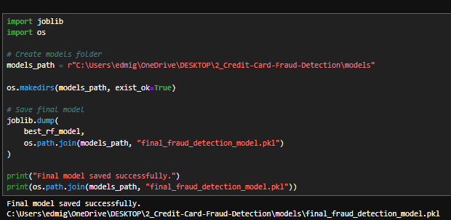

Part F — Step 2: Save Model Configuration
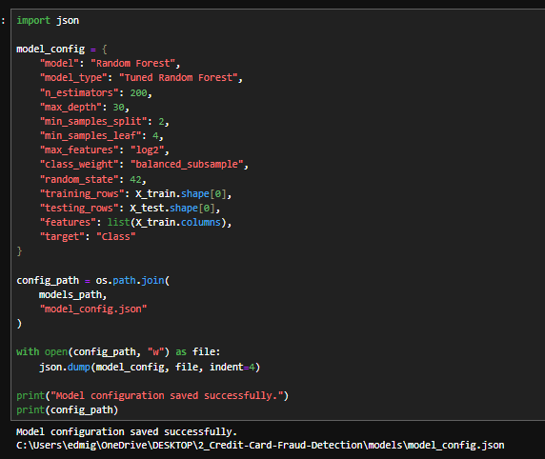

Part F — Step 3: Test That the Saved Model Can Be Loaded
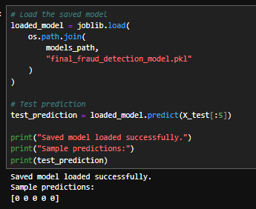
Model Reproducibility and Saving
The final tuned Random Forest model was saved using the Joblib serialization library to allow the trained model to be reused without retraining. The model configuration, including hyperparameters, random state, feature names, target variable, and training and testing dataset sizes, was also saved as a JSON configuration file.
The saved model was subsequently loaded and tested to verify that the serialized model could be successfully restored and used for prediction. This process supports reproducibility and provides the necessary model artifacts for future deployment.

Step 4 Summary
Part 4
Part A — Train/Test Split
Part B — Baseline Models
Part C — Evaluation & Comparison
Part D — Hyperparameter Tuning
Part E — Final Model Selection
Part F — Save Model & Configuration

STEP 5 — Critical Thinking, Ethical AI & Bias Auditing

STEP 5 → Part A — Model Explainability using SHAP

Step 1 — Import SHAP
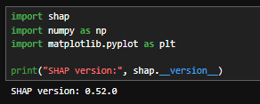

Step 2 — Create SHAP Explainer
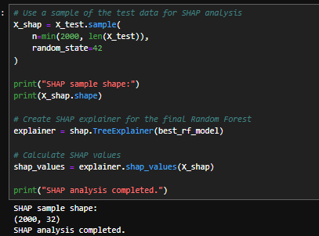

Step 3 — Prepare SHAP Values for Fraud Class
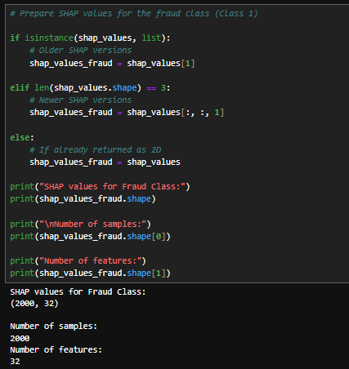

Step 4 — SHAP Summary Plot
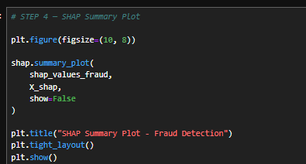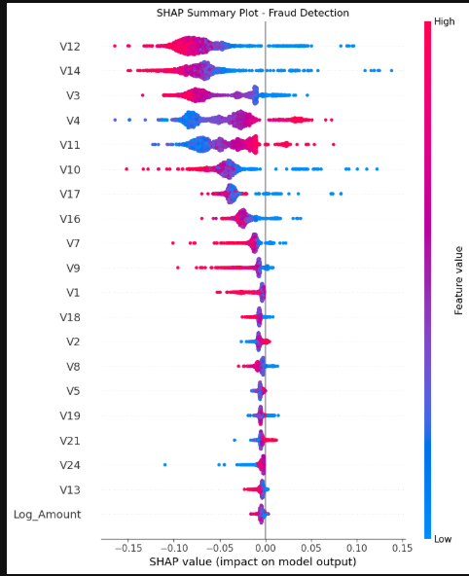

Step 5 — SHAP Feature Importance
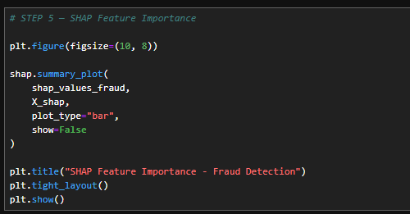
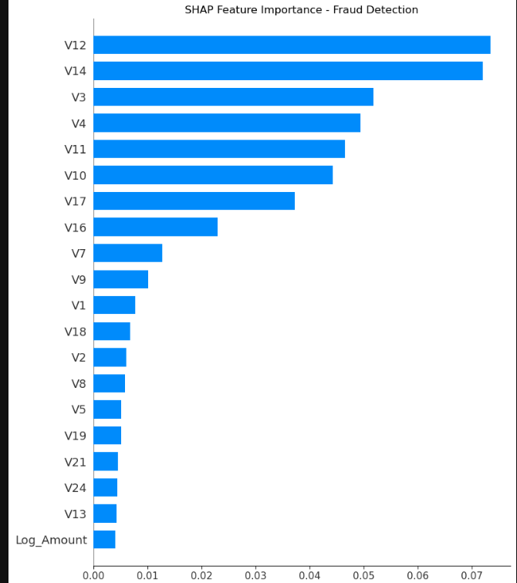

Step 6 — Local SHAP Explanation
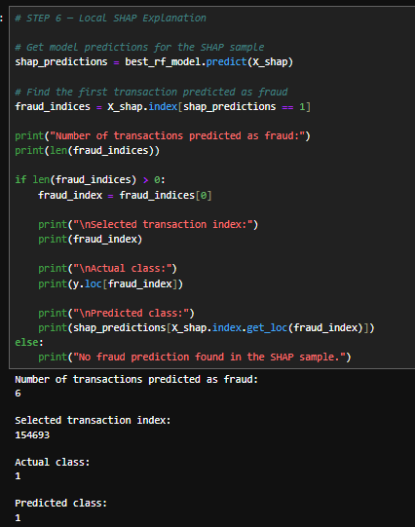

Step 7 — Visualize the Local Explanation
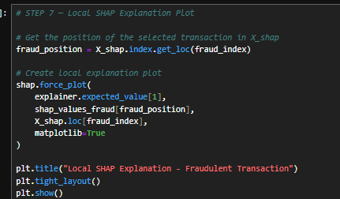
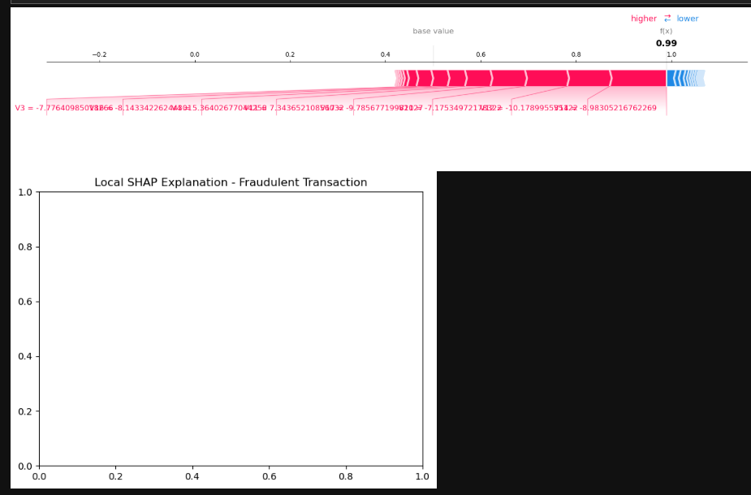

Step 8 — Waterfall Plot for Local Explanation
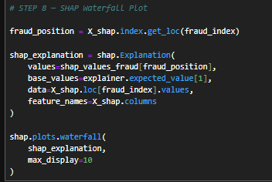
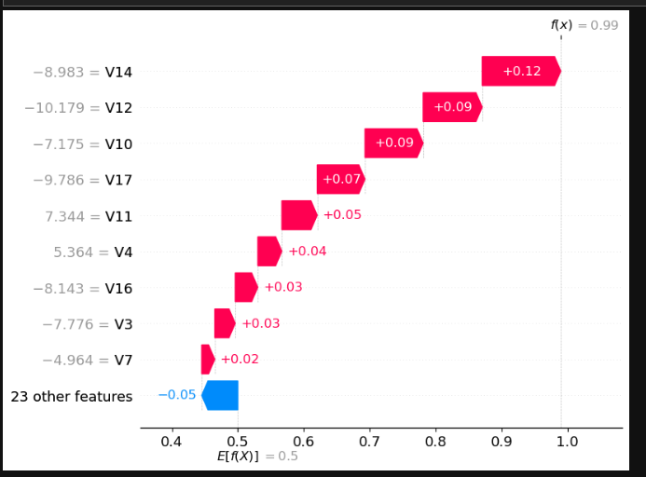

STEP 5 → Step 9 — SHAP Interpretation Summary
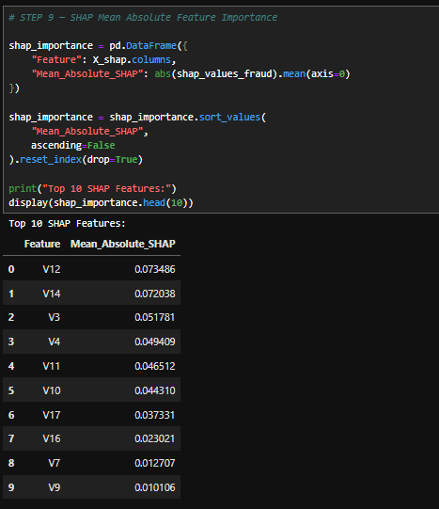

STEP 5 → Part B — PDP / ICE

Step 1 — Select a Feature for PDP/ICE
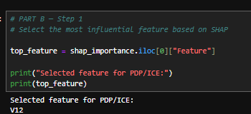

Step 2 — Create Partial Dependence Plot (PDP)

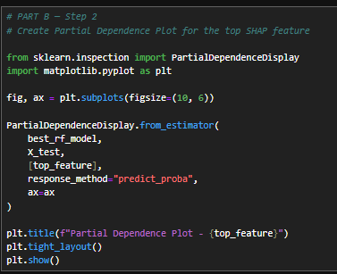
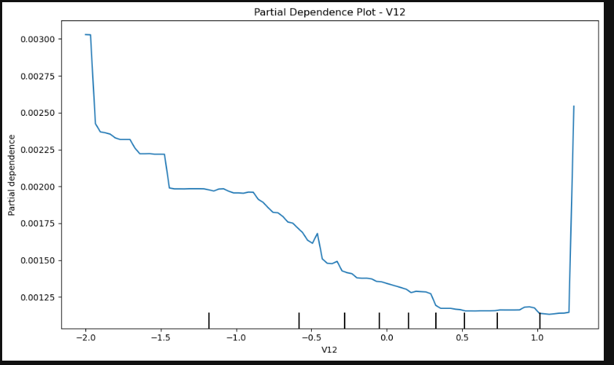

Step 3 — ICE Plot
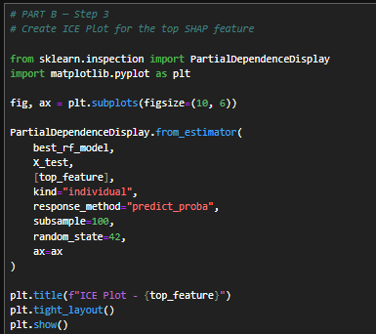
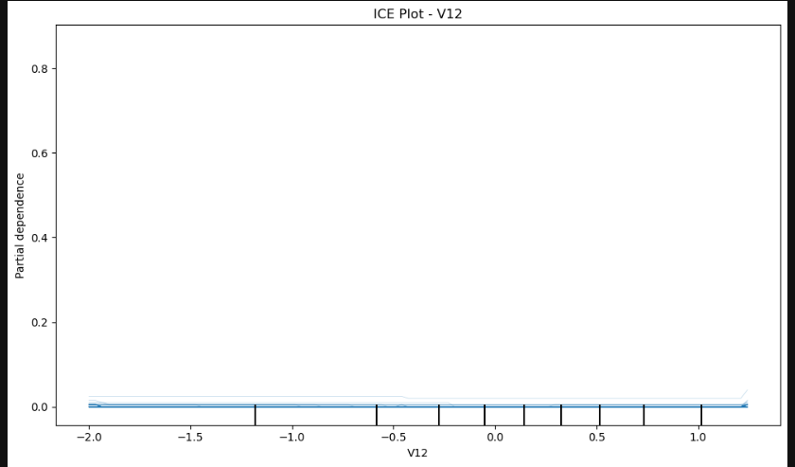

“ICE analysis was performed to examine how changes in the V12 feature affect fraud predictions across individual transactions. Unlike the PDP, which represents the average relationship, ICE provides transaction-level variation in the model response.”

Step 4 — Interpret PDP and ICE Results
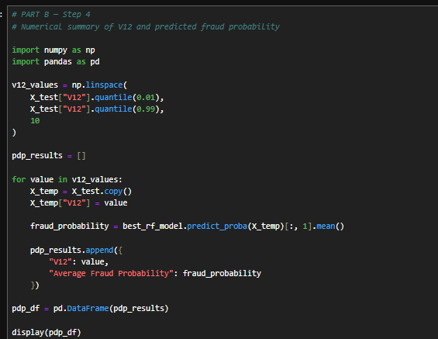
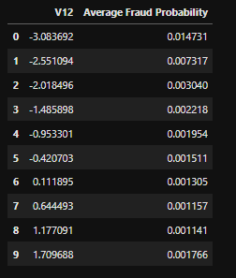

Step 5 — Final PDP/ICE Interpretation
Partial Dependence and Individual Conditional Expectation Analysis
Partial Dependence (PDP) and Individual Conditional Expectation (ICE) were used to further investigate the relationship between the most influential SHAP feature, V12, and the model's fraud predictions. The PDP provides an average view of how changes in V12 affect the model's predicted probability of fraud, while the ICE analysis examines how this relationship varies across individual transactions. Differences among individual ICE curves indicate that the effect of V12 may vary across transactions rather than following one identical pattern for all observations. These analyses provide additional model interpretability beyond global feature importance and individual SHAP explanations. However, the observed relationships should not be interpreted as causal effects. Furthermore, because V12 is an anonymized feature, its specific real-world business meaning cannot be determined from the dataset.

Step 5 Part B Summary
Activity
Select top SHAP feature
PDP
ICE
Numerical PDP analysis
Interpretation

STEP 5 → Part C — Model Limitations

Step 1 — Class Imbalance Analysis
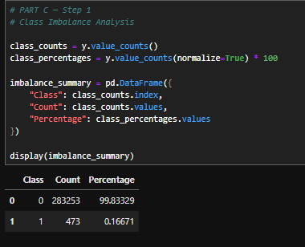
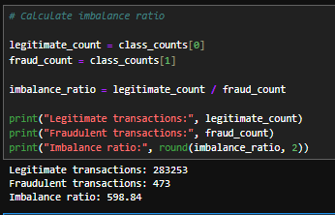

Step 2 — Data Leakage Analysis
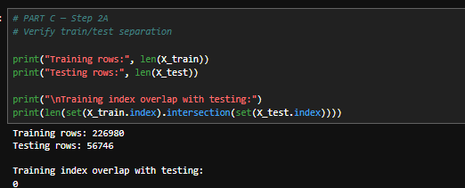

Step 3 — Overfitting Analysis
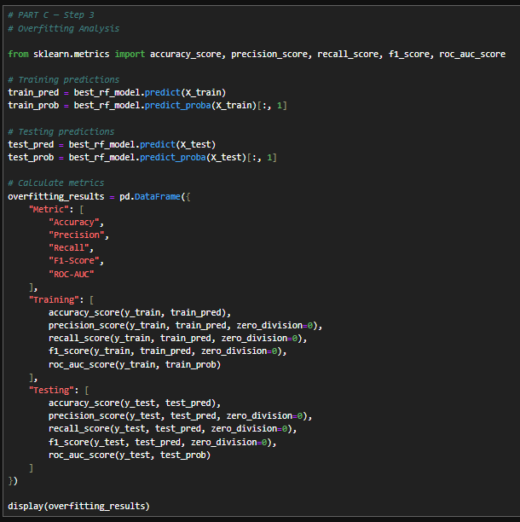
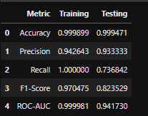

Step 4 — False Positive & False Negative Analysis
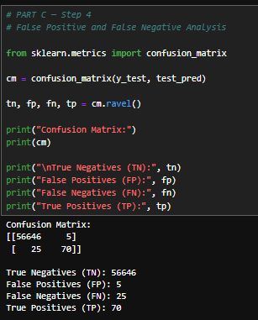
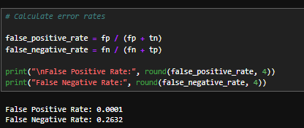

Step 5 — Limitations Summary
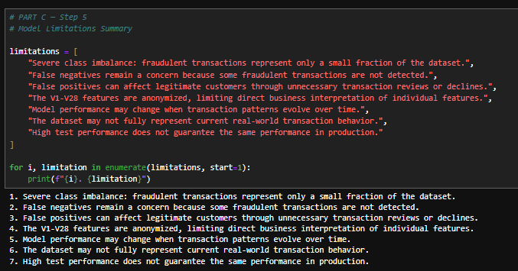
Model Limitations
Several limitations were identified during the evaluation of the fraud detection model. First, the dataset is highly imbalanced, with fraudulent transactions representing only a very small proportion of observations. Therefore, accuracy alone is not sufficient for evaluating model performance. Second, the final model achieved a false negative rate of 26.32%, indicating that some fraudulent transactions were not detected. False positives also remain relevant because incorrectly flagging legitimate transactions may result in unnecessary reviews or customer inconvenience. In addition, the V1–V28 variables are anonymized, limiting the ability to provide direct business interpretations of individual features. Finally, model performance may change when transaction behavior evolves, meaning that the model would require ongoing monitoring and periodic validation if deployed in a real-world environment.

STEP 5 → Part D — Bias Audit

Step 1 — Identify Available Sensitive Attributes
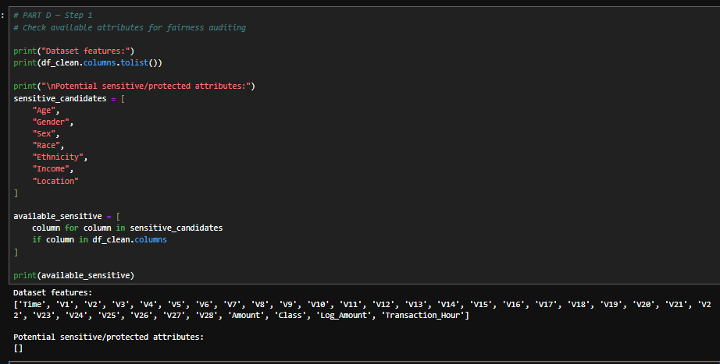

Step 2 — Operational Subgroup Audit
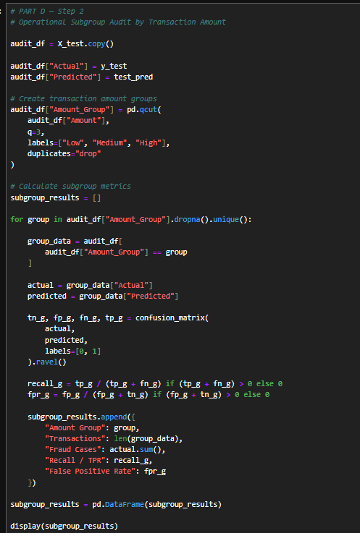
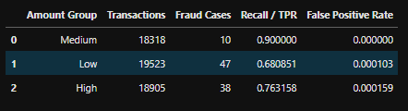
“Performance was examined across transaction-amount subgroups to identify potential differences in model behavior. Because the dataset does not contain explicit protected attributes, this analysis does not establish demographic fairness.”
Amount Group | Transactions | Fraud Cases | Recall / TPR | False Positive Rate
Medium | 18,318 | 10 | 90.00% | 0.00%
Low | 19,523 | 47 | 68.09% | 0.01%
High | 18,905 | 38 | 76.32% | 0.02%

Operational Subgroup Audit
Because the dataset does not contain explicit demographic or protected-group attributes, a conventional demographic fairness audit could not be performed. Instead, an operational subgroup analysis was conducted by dividing transactions into low, medium, and high transaction-amount groups. Model performance varied across these groups. Recall ranged from 68.09% for low-value transactions to 90.00% for medium-value transactions and 76.32% for high-value transactions. False positive rates remained very low across all groups, ranging from 0% to 0.0159%. However, the medium-value group contained only 10 fraudulent transactions, so its 90% recall should be interpreted cautiously. These results demonstrate that model performance can vary across operational subgroups, but they do not establish demographic fairness because protected attributes were not available.

Step 3 — Fairness Metrics Summary
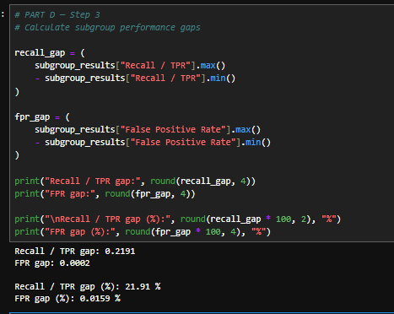

Step 4 — Bias Audit Conclusion

Bias Audit Conclusion
A conventional protected-group fairness assessment could not be performed because the dataset does not contain explicit demographic or protected attributes. To identify potential differences in model behavior, an operational subgroup audit was conducted using transaction-amount groups. The analysis showed a Recall/TPR gap of 21.91 percentage points across the groups, while the False Positive Rate gap was only 0.0159 percentage points. This indicates that fraud-detection performance varied across transaction-amount groups, particularly in terms of recall. However, these findings should not be interpreted as evidence of demographic bias because transaction amount is not a protected attribute. The limited number of fraudulent transactions in some subgroups also means that subgroup-level estimates should be interpreted cautiously.
Step 5 Part D Summary
Activities
Identify sensitive attributes
Explain absence of protected attributes
Operational subgroup audit
Recall/TPR comparison
FPR comparison
Performance gaps
Fairness limitation documented

STEP 5 → Part E — Bias & Risk Mitigation Strategies

Step 1 — Define Mitigation Strategies
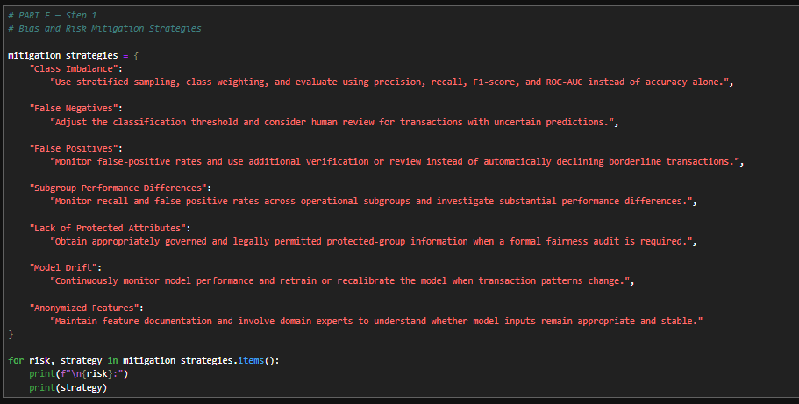
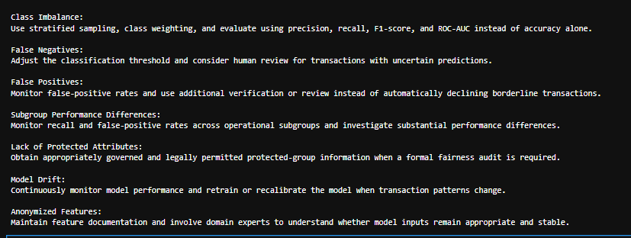
Bias and Risk Mitigation
Several mitigation strategies can be applied to address the identified risks. Class imbalance can be managed through stratified sampling, class weighting, and evaluation using metrics such as precision, recall, F1-score, and ROC-AUC. False negatives can be reduced by evaluating alternative classification thresholds and introducing human review for uncertain transactions. False positives should also be monitored to reduce unnecessary customer friction. Differences in model performance across operational subgroups should be continuously monitored using subgroup-level recall and false-positive rates. Since the dataset does not contain protected demographic attributes, formal fairness assessments would require appropriately governed and legally permitted data. Finally, production deployment should include model monitoring and periodic retraining to address changes in transaction behavior and model drift.

Step 2 — Ethical AI Checklist
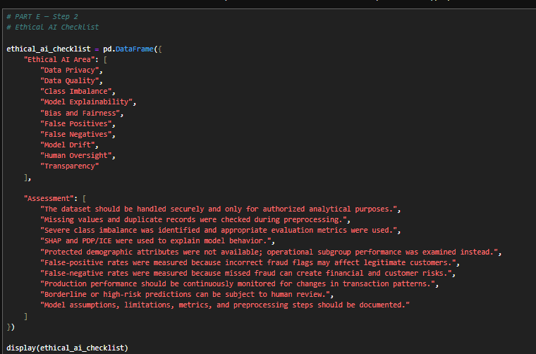
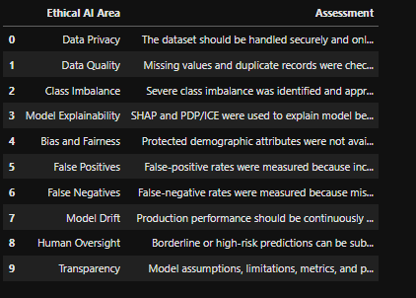
Ethical considerations were incorporated throughout the development of the credit card fraud detection system. Data quality was assessed through missing-value and duplicate checks, while the severe class imbalance was considered during model evaluation. Model explainability was addressed using SHAP and PDP/ICE techniques. A conventional protected-group fairness audit could not be performed because the dataset does not contain explicit demographic attributes; therefore, an operational subgroup analysis was conducted and this limitation was documented. False positives and false negatives were also evaluated because both can create different risks for customers and the financial institution. For potential production deployment, human oversight, model monitoring, drift detection, periodic validation, and transparent documentation should be implemented.

Step 5 Summary
Step 5 Requirement
SHAP / Explainability
PDP / ICE
Class imbalance limitations
Data leakage analysis
Overfitting analysis
False Positive / False Negative analysis
Bias audit
Fairness limitation
Mitigation strategies
Ethical AI checklist

STEP 6 — Final Presentation & Communication

PART A — TECHNICAL PRESENTATION
Page | Slide Title | Rubric Covered
1 | Project Overview | Introduction
2 | Problem & Objective | Problem understanding
3 | Dataset & Data Understanding | Dataset + data overview
4 | Data Preprocessing & EDA | Preprocessing + visuals
5 | Feature Engineering & Selection | Feature engineering
6 | Dimensionality Reduction | PCA
7 | Model Development | Multiple ML models
8 | Model Comparison & Final Model | Metrics + model selection
9 | Explainability, Ethics & Bias | SHAP, PDP/ICE, limitations, bias
10 | Conclusion & Future Work | Final technical findings

Page 1 — Project Overview
Credit Card Fraud Detection System Using Machine Learning
An Intelligent Approach to Detecting Fraudulent Transactions
Presented by:
Ed Miguel Paraiso
AI & Machine Learning Capstone Project
Credit Card Transaction
↓
Machine Learning Model
↓
🟢 Legitimate / 🔴 Fraud

Speaker notes:
“Good day everyone. My capstone project focuses on developing a machine learning-based credit card fraud detection system. The objective is to identify potentially fraudulent transactions and distinguish them from legitimate transactions using historical transaction data.”

Page 2 — Problem & Objective
Problem
Credit card fraud detection is challenging because fraudulent transactions represent only a very small portion of total transactions.
Our cleaned dataset contains:
283,726 transactions
283,253 legitimate
473 fraudulent
0.17% fraud rate
Objective
Develop a machine learning system that can classify credit card transactions as legitimate or fraudulent while maintaining a good balance between detecting fraud and minimizing false alarms.
283,726 Transactions
↓
┌───────────────┐
│ ML Model │
└───────┬───────┘
↓
┌───────┴────────┐
↓ ↓
LEGITIMATE FRAUD
283,253 473
Speaker notes
“The main challenge of this project is the highly imbalanced nature of credit card fraud data. In the cleaned dataset, only 473 out of 283,726 transactions were fraudulent. Because fraudulent transactions are rare, a model could achieve high accuracy while still missing many fraudulent transactions. Therefore, this project focuses on precision, recall, F1-score, and ROC-AUC to evaluate the model more appropriately.”

Page 3 — Dataset & Data Understanding
Dataset Overview
Item | Details
Original records | 284,807
Cleaned records | 283,726
Features | 30 original + 2 engineered
Target | Class
Legitimate | 283,253 (99.83%)
Fraudulent | 473 (0.17%)
Missing values | 0
Duplicate records removed | 1,081
Main Variables
- Time — elapsed time of the transaction
- V1–V28 — anonymized PCA-transformed numerical features
- Amount — transaction amount
- Class — target variable
  - 0 = Legitimate
  - 1 = Fraud

Class Distribution bar chart
Legitimate █████████████████████████████████ 99.83%
Fraud ▏ 0.17%
Speaker notes
“The dataset initially contained 284,807 transactions and 31 columns. During preprocessing, 1,081 duplicate records were removed, resulting in 283,726 transactions. The dataset contains 30 original input variables, including Time, V1 to V28, and Amount, with Class as the target variable. The dataset is highly imbalanced, with fraudulent transactions representing only 0.17 percent of the cleaned data. There were no missing values. The V1 to V28 variables are anonymized PCA-transformed features, so their specific business meanings cannot be directly interpreted.”

Page 4 — Data Preprocessing & EDA
Data Preprocessing
- Removed 1,081 duplicate records
- Confirmed 0 missing values
- Retained potential outliers because unusual values may contain fraud signals
- Applied stratified train-test split
  - 80% Training
  - 20% Testing
Exploratory Data Analysis
Key findings:
- Fraud represents only 0.17% of transactions
- Transaction Amount is strongly right-skewed
- Fraud and legitimate transactions show overlapping amount distributions
- Transaction Time shows different distribution patterns between groups
- Correlation analysis identified several V-features with stronger relationships to the fraud target
Speaker notes
“The preprocessing stage began by removing 1,081 duplicate records and confirming that there were no missing values. Potential outliers were not automatically removed because unusual transaction patterns may contain useful fraud signals. Exploratory data analysis showed that fraudulent transactions account for only 0.17 percent of the cleaned dataset. Transaction amounts were strongly right-skewed, while fraud and legitimate transactions showed overlapping distributions. These findings reinforced the need for appropriate preprocessing and evaluation metrics for an imbalanced classification problem.”

Page 5 — Feature Engineering & Selection
Feature Engineering
We created two additional features:
1. Log_Amount
- log1p(Amount)
- Reduces the effect of the highly right-skewed transaction amount.
2. Transaction_Hour
- Derived from Time
- Provides an additional temporal representation of the transaction.
Feature Selection
Used Mutual Information (MI) to identify features with stronger relationships with the fraud target.
Top features included:
V17 | V14 | V12 | V10 | V11

Original Features
↓
Feature Engineering
↓
Log_Amount
Transaction_Hour
↓
Mutual Information
↓
Selected Important Features

Speaker notes
“Feature engineering was performed to create additional information that could improve the model's ability to identify fraudulent transactions. Log_Amount was created to reduce the strong skewness of transaction amounts, while Transaction_Hour provided an additional temporal representation. Mutual Information was then used as a data-driven feature selection method to identify features with stronger relationships with the fraud target. Features such as V17, V14, V12, V10, and V11 showed relatively high mutual information scores.”

Page 6 — Dimensionality Reduction (PCA)
Principal Component Analysis (PCA)
- Applied StandardScaler before PCA
- Starting input: 32 features
- PCA was used to examine dimensionality reduction
- 28 principal components retained
- Explained variance: 96.19%
32 Features
↓
StandardScaler
↓
PCA
↓
28 Components
↓
96.19% Variance Retained

Speaker notes
“Principal Component Analysis was used as a dimensionality reduction technique. The 32 input features were standardized before applying PCA. The analysis showed that 28 principal components were required to retain at least 95 percent of the total variance, resulting in approximately 96.19 percent explained variance. PCA was primarily used for exploratory dimensionality analysis. The final Random Forest model was trained using the original engineered feature space rather than the PCA-transformed features.”

Page 7 — Machine Learning Models
Models Implemented
We evaluated five supervised machine learning algorithms:
- Logistic Regression
- Decision Tree
- Random Forest
- Gradient Boosting
- XGBoost
Training Data
↓
Multiple ML Models
↓
Baseline Evaluation
↓
Hyperparameter Tuning
↓
Final Model
Hyperparameter Tuning
Two models were further tuned using RandomizedSearchCV:
- Random Forest
- XGBoost
Evaluation focused particularly on:
Precision | Recall | F1-Score | ROC-AUC
because of the severe class imbalance.
Model | Type
Logistic Regression | Linear
Decision Tree | Tree-based
Random Forest | Ensemble
Gradient Boosting | Ensemble
XGBoost | Gradient boosting

Speaker notes
“Five supervised machine learning models were implemented and compared: Logistic Regression, Decision Tree, Random Forest, Gradient Boosting, and XGBoost. These models provided different approaches to the binary fraud classification problem. After baseline evaluation, Random Forest and XGBoost were selected for further hyperparameter tuning using RandomizedSearchCV. Model performance was evaluated using precision, recall, F1-score, and ROC-AUC, with particular attention to recall and F1-score because of the severe class imbalance.”

Page 8 — Model Comparison & Final Model
Model | Precision | Recall | F1 | ROC-AUC
Logistic Regression | 5.51% | 87.37% | 10.36% | 96.83%
Decision Tree | 70.73% | 61.05% | 65.54% | 80.51%
Random Forest | 97.10% | 70.53% | 81.71% | 91.93%
Gradient Boosting | 86.11% | 63.16% | 74.25% | 85.39%
XGBoost | 95.71% | 70.53% | 81.21% | 97.17%

Model | Precision | Recall | F1 | ROC-AUC
Tuned Random Forest | 93.33% | 73.68% | 82.35% | 94.17%
Tuned XGBoost | 95.77% | 71.58% | 81.93% | 97.49%

Key test results:
Accuracy: 99.95%
Precision: 93.33%
Recall: 73.68%
F1-Score: 82.35%
ROC-AUC: 94.17%
Speaker notes
“Five baseline models were compared using multiple evaluation metrics. Logistic Regression achieved high recall but produced very low precision, resulting in many false-positive predictions. Random Forest and XGBoost provided substantially better precision and F1-score. After hyperparameter tuning, the Random Forest achieved a recall of 73.68 percent and an F1-score of 82.35 percent, while maintaining 93.33 percent precision. Tuned XGBoost achieved higher precision and ROC-AUC, but the tuned Random Forest achieved higher recall and F1-score. Based on the project's emphasis on detecting fraudulent transactions while maintaining reasonable false-positive performance, the tuned Random Forest was selected as the final model.”

Page 9 — Explainability, Ethics & Bias
Model Explainability
SHAP
- Identified the features influencing fraud predictions
- V12 was the top SHAP feature in our analysis
- Local SHAP explanations showed why individual transactions were classified as fraud
PDP & ICE
- Examined how changes in V12 affect predicted fraud probability
- Compared average behavior with individual transaction behavior
Ethical AI & Bias Audit
- Dataset has no explicit demographic/protected attributes
- Therefore, conventional demographic fairness could not be directly measured
- Conducted an operational subgroup audit by transaction amount
- Recall/TPR gap: 21.91 percentage points
- FPR gap: 0.0159 percentage points
- False Negative Rate: 26.32%
Key Risks
Missed fraud → financial risk
False alerts → customer inconvenience
Model drift → changing performance
SHAP
↓
Feature Importance
↓
V12
↓
Individual Prediction

No Protected Attributes
↓
Operational Audit
↓
Recall Gap: 21.91 pp
FPR Gap: 0.0159 pp
Speaker notes
“To improve model transparency, SHAP was used to explain both global feature importance and individual fraud predictions. PDP and ICE were also used to examine how changes in the most influential feature affected model predictions. For ethical AI, the dataset did not contain explicit demographic or protected attributes, so a conventional demographic fairness audit could not be performed. Instead, an operational subgroup audit based on transaction amount was conducted. The analysis showed a 21.91 percentage-point gap in recall across the groups, while the false-positive-rate gap was only 0.0159 percentage points. These findings demonstrate the importance of monitoring model performance across different transaction groups without claiming demographic fairness from unavailable data.”

Page 10 — Conclusion & Future Work
Key Findings
- Developed a supervised ML system for credit card fraud detection
- Evaluated 5 machine learning models
- Tuned Random Forest and XGBoost
- Final model: Tuned Random Forest
- F1-Score: 82.35%
- Recall: 73.68%
- Precision: 93.33%
- ROC-AUC: 94.17%
Future Work
- Threshold optimization
- Real-time transaction scoring
- Model drift monitoring
- Periodic retraining
- Additional fairness/protected-group analysis when appropriate data is available
- Integration with a transaction monitoring workflow
- Human review for uncertain/high-risk transactions
Speaker notes
“In conclusion, this project developed and evaluated a machine learning-based credit card fraud detection system. Five classification models were compared, with Random Forest and XGBoost undergoing further hyperparameter tuning. The tuned Random Forest was selected as the final model and achieved 93.33 percent precision, 73.68 percent recall, 82.35 percent F1-score, and 94.17 percent ROC-AUC on the test set. The project also incorporated model explainability, ethical considerations, and subgroup analysis. For future development, the system could be improved through threshold optimization, real-time scoring, model drift monitoring, periodic retraining, and integration with human review and transaction monitoring processes.”

PART B — BUSINESS PRESENTATION
Page | Slide Title | Rubric Covered
1 | Business Problem | Why fraud detection matters
2 | Current Business Challenge | Fraud, losses, customer impact
3 | Proposed AI Solution | How the system helps
4 | How the Solution Works | Simple non-technical workflow
5 | Model Performance | Key results in business terms
6 | Business KPIs | Fraud detection, FPR, FNR, review rate
7 | Business Value & ROI Framework | Potential savings/value
8 | Risks & Ethical Considerations | False positives, missed fraud, fairness
9 | Implementation Strategy | Pilot → monitoring → deployment
10 | Recommendation & Next Steps | Practical implementation roadmap

Page 1 — Business Problem
Credit Card Fraud Detection
Using AI to Support Safer Transaction Monitoring
The Business Challenge
Credit card fraud can create:
- Financial losses from fraudulent transactions
- Customer impact when legitimate transactions are incorrectly flagged
- Manual investigation workload
- Need for faster transaction screening
- Changing fraud patterns over time
Business Goal
Use machine learning to help identify potentially fraudulent transactions earlier while balancing fraud detection with customer experience.
CUSTOMER TRANSACTION
↓
AI SCREENING
↓
┌──────┴──────┐
↓ ↓
LOW RISK HIGH RISK
↓ ↓
PROCEED REVIEW / ACTION
Speaker notes
“Credit card fraud creates both financial and operational challenges for financial institutions. The business needs to identify potentially fraudulent transactions quickly while minimizing unnecessary disruption to legitimate customers. This project proposes a machine learning-based screening system that can support transaction monitoring by identifying transactions that may require further investigation.”

Page 2 — Current Business Challenge & Impact
1. Financial Impact
Fraudulent transactions can result in:
- Direct financial losses
- Fraud investigation and recovery costs
- Potential chargeback-related costs
2. Customer Impact
False fraud alerts can cause:
- Legitimate transactions to be declined or reviewed
- Customer inconvenience
- Reduced transaction confidence
3. Operational Impact
Large transaction volumes can create:
- Manual review workload
- Longer investigation time
- Pressure on fraud operations teams
4. Changing Fraud Patterns
Fraud behavior can change over time, requiring:
- Continuous monitoring
- Model validation
- Periodic model updates
Speaker notes
“Fraud detection is not only a technical problem. It has financial, customer, and operational consequences. Fraudulent transactions can create financial losses and investigation costs, while excessive false alerts can inconvenience legitimate customers. At the same time, manually reviewing large transaction volumes can increase operational workload. Because fraud patterns can also change over time, a fraud detection solution needs continuous monitoring and validation.”

Page 3 — Proposed AI Solution

Proposed AI-Assisted Fraud Detection
The proposed system uses machine learning to:
- Analyze transaction patterns
- Estimate fraud risk
- Identify potentially fraudulent transactions
- Prioritize transactions for review
- Support fraud operations teams
TRANSACTION
↓
DATA PROCESSING
↓
AI / ML FRAUD MODEL
↓
RISK PREDICTION
↓
┌──────────────┬──────────────┐
↓ ↓ ↓
LOW RISK REVIEW NEEDED HIGH RISK
↓ ↓ ↓
Proceed Manual Investigation
Review

Business Value
Faster screening
→ Helps process large transaction volumes
Prioritized investigations
→ Focus human resources on higher-risk cases
Consistent detection
→ Applies the same trained model across transactions
Customer protection
→ Supports earlier identification of potentially fraudulent activity

Speaker notes
“The proposed solution is an AI-assisted fraud detection system. Instead of relying entirely on manual review, the system analyzes transaction patterns and generates a fraud prediction. Transactions can then be prioritized based on their risk level. Lower-risk transactions may continue through the normal process, while higher-risk or uncertain transactions can be routed for additional verification or investigation. The purpose is to support fraud operations rather than completely replace human decision-making.”

Page 4 — How the Solution Works
From Transaction to Fraud Risk
CUSTOMER TRANSACTION
↓
TRANSACTION DATA
↓
DATA PREPROCESSING
↓
MACHINE LEARNING
MODEL
↓
FRAUD RISK SCORE
↓
┌─────────┴─────────┐
↓ ↓
LOW RISK HIGH RISK
↓ ↓
Normal Processing Further Review
↓
Human Investigation
Stage | Simple description
Transaction | Customer makes a transaction
Data | Transaction information is captured
ML Analysis | Model analyzes transaction patterns
Risk Prediction | Transaction receives a fraud prediction
Business Action | Proceed, review, or investigate

Speaker notes
“The proposed workflow begins when a customer performs a transaction. Relevant transaction information is processed and provided to the machine learning model. The model analyzes patterns learned from historical data and produces a fraud prediction. Based on the risk level and the institution's business rules, transactions can either continue normally or be routed for additional review. Human investigators remain important for high-risk or uncertain cases.”

Page 5 — Model Performance & Business Results
What Did the AI Achieve?
Metric | Result
Precision | 93.33%
Recall | 73.68%
F1-Score | 82.35%
ROC-AUC | 94.17%
Accuracy | 99.95%

Business Interpretation
93.33% Precision
→ Most transactions flagged by the model as fraud were actually fraudulent.
73.68% Recall
→ The model detected approximately 74% of the fraudulent transactions in the test set.
26.32% False Negative Rate
→ Some fraudulent transactions were still missed.
99.95% Accuracy
→ High overall accuracy, but it should not be used alone because fraud is extremely rare.

Speaker notes
“The final tuned Random Forest achieved 93.33 percent precision, meaning that most transactions identified as potentially fraudulent were actually fraudulent in the test data. The model achieved 73.68 percent recall, meaning it detected approximately 74 percent of the fraudulent transactions in the test set. Its F1-score was 82.35 percent and ROC-AUC was 94.17 percent. Although overall accuracy was 99.95 percent, accuracy should not be interpreted alone because fraudulent transactions represent only a very small portion of the dataset.”

Page 6 — Business KPIs
How Should the Business Measure Success?
Business KPI | What it Measures
Fraud Detection Rate | Percentage of actual fraud detected
False Positive Rate | Legitimate transactions incorrectly flagged
False Negative Rate | Fraudulent transactions missed
Review Rate | Percentage of transactions requiring human review
Fraud Value Identified | Monetary value of potentially fraudulent transactions detected
Customer Impact | Legitimate customers affected by fraud controls

Current Project Results
Fraud Detection Rate / Recall: 73.68%
False Positive Rate: 0.01%
False Negative Rate: 26.32%
Speaker notes
“For business deployment, model metrics should be translated into operational KPIs. The current test results show a fraud detection rate of 73.68 percent, a false positive rate of approximately 0.01 percent, and a false negative rate of 26.32 percent. Additional business KPIs such as review rate and fraudulent transaction value identified would require operational data that is not available in the current public dataset. These metrics should therefore be included in a future production pilot.”

Page 7 — Business Value & ROI Framework
Potential Business Value
The AI system can potentially create value through:
1. Reduced Fraud Losses
Earlier identification of suspicious transactions may help reduce preventable fraud losses.
2. Operational Efficiency
Risk-based screening can help prioritize transactions for investigation.
3. Customer Protection
Reducing unnecessary false alerts can help minimize disruption to legitimate customers.
4. Scalable Monitoring
A machine-learning system can support screening across large transaction volumes.
Data Needed for Actual ROI
To calculate actual Philippine-peso ROI, we would need:
- Historical fraud losses
- Average fraud transaction value
- Cost per manual investigation
- Number of transactions reviewed
- Recovery rate
- Implementation and maintenance cost
- Customer-impact costs
Speaker notes
“The proposed system can potentially generate business value by helping identify fraudulent activity earlier, prioritizing investigations, reducing unnecessary manual work, and supporting scalable transaction monitoring. However, an actual return-on-investment figure cannot be calculated from the current public dataset because it does not contain institutional fraud-loss, operational-cost, or recovery data. Therefore, an ROI framework is proposed. During a production pilot, the organization could populate this framework with actual financial and operational data to determine the system's realized business value.”

Page 8 — Risks & Ethical Considerations
Risk | Potential Business Impact | Mitigation
False Negatives | Fraud may be missed | Threshold optimization + monitoring
False Positives | Legitimate customers may be disrupted | Verification / human review
Model Drift | Detection performance may decline | Continuous monitoring + retraining
Data Privacy | Customer information could be exposed | Secure data governance
Bias / Unequal Performance | Some transaction groups may experience different detection rates | Subgroup monitoring
Over-reliance on AI | Incorrect automated decisions | Human oversight

Speaker notes
“The proposed system also has important risks. The most significant technical risk is false negatives, where fraudulent transactions are not detected. False positives can also affect legitimate customers through unnecessary reviews or transaction disruption. Model performance may change as transaction behavior evolves, creating model drift. Data privacy and fairness must also be considered. For these reasons, the proposed solution should operate with appropriate monitoring, human oversight, secure data governance, and periodic model validation rather than relying entirely on automated predictions.”

Page 9 — Implementation Strategy
Phase 1 — Pilot
- Test the model using historical transactions
- Validate performance against business KPIs
- Establish fraud-review thresholds
↓
Phase 2 — Controlled Deployment
- Integrate with transaction monitoring
- Use AI for risk scoring/screening
- Route uncertain or high-risk cases to human review
↓
Phase 3 — Monitoring
- Track precision, recall, FPR, FNR
- Monitor subgroup performance
- Monitor model drift
- Review false positives and false negatives
↓
Phase 4 — Continuous Improvement
- Periodically retrain/recalibrate the model
- Update thresholds based on business requirements
- Incorporate new fraud patterns
- Continue governance and validation
Speaker notes
“A practical implementation should begin with a controlled pilot rather than immediate full-scale deployment. During the pilot, historical and controlled transaction data can be used to validate the model against business KPIs. The next phase would introduce the model into transaction monitoring as a risk-screening tool, with human review for uncertain or high-risk cases. After deployment, model performance, false positives, false negatives, subgroup performance, and model drift should be continuously monitored. Finally, the model should be periodically recalibrated or retrained as transaction and fraud patterns evolve.”

Page 10 — Recommendation & Next Steps
Conclusion & Next Steps
What the Project Demonstrated
✅ Machine learning can support credit card fraud screening
✅ Multiple models were evaluated and tuned
✅ Final model achieved 93.33% precision and 73.68% recall
✅ Explainability was incorporated using SHAP and PDP/ICE
✅ Operational subgroup performance and ethical risks were assessed
Recommended Next Steps
1. Pilot
Validate the model using real operational transaction data.
2. Optimize
Tune decision thresholds based on fraud-loss and customer-impact objectives.
3. Integrate
Connect risk scoring with the existing fraud-monitoring workflow.
4. Monitor
Track model performance, drift, false positives, false negatives, and subgroup differences.
5. Improve
Retrain and recalibrate the model as fraud patterns change.
Speaker notes
“This project demonstrates how machine learning can support credit card fraud detection by screening transactions and identifying potentially fraudulent patterns. The final model achieved 93.33 percent precision and 73.68 percent recall on the test data. However, successful business deployment requires more than model performance. The next steps should include a controlled pilot using real operational data, threshold optimization based on business requirements, integration with existing monitoring processes, continuous performance and drift monitoring, and periodic model improvement. The proposed approach is therefore AI-assisted rather than fully autonomous, combining machine learning with appropriate human oversight.”

